Fiscal Deficit and Inflation reduction in Pakistan: Full-reserve vs. Fractional-reserve Banking Model (2015-2025). A Comparative Analysis
Muhammad Ashar Fayyaz

MPhil Student NUML Islamabad
muhammadasharfayyaz@gmail.com

Abstract
The economy of Pakistan is plagued by a long-running crisis known as the twin deficit, which is typified by an unpayable national debt of PRs. 80.5 trillion and a continuous inflation. In this paper, the author claims that these fiscal pathologies are symptoms of the Fractional-Reserve Banking (FRB) design, which privatizes money creation and requires exponential growth in debts. Through the application of a comparative research paradigm, this research paper models the change of the monetary system of Pakistan to the Full-Reserve Banking system using the parameters of the Chicago Plan Revisited developed by the IMF to the fiscal data of FY-2025. Through the analysis, it can be noted that the current system incurs an estimated PRs. 12.36 trillion in interest transfers and lost seigniorage to the exchequer every year. According to quantitative projections that a 100% reserve requirement would carry out a so-called Debt-for-Reserves swap, improving the current stock of public debt by 63.6% at once. According to the findings, the sole structural solution is the reclaiming of sovereign power over the creation of money to eradicate the fiscal deficit, price stability and to make the economy congruent with the Islamic principles of wealth preservation (Hifz al-Mal) and justice (Adl).
Keywords: Full-Reserve banking, Seigniorage, Public Debt, Fractional-Reserve banking, Chicago Plan, Islamic Monetary Policy, Pakistan Economy.
Introduction
The last several decades have been marked by a paradox in the economic history of Pakistan: the increase in tax collection and the implementation of austerity policies have not led to a decrease in the national debt, which is growing exponentially. The crisis is common to each fiscal year, a growing deficit that must lead to further borrowing not to develop the nation, but just to settle interest on the already existing loans. With the public debt amounting to an all-time high of PRs. 80.5 trillion and interest payments taking up 8.9 trillion of the federal budget (State Bank of Pakistan [SBP], 2025) as of June 2025, much of the policy discussion has been on symptomatic solutions to this issue: raising tax income, privatizing state assets, or trying to get bailouts. But these steps never succeed in halting the debt build up. This paper contends that, the very foundation of this instability is more than a failure in mismanagement of finances and is entrusted in the very fabric of our monetary system.
The very process of money creation is the inherent vice of the modern economy. In the present Fractional-Reserve Banking (FRB) system, the money in circulation is not created by the State or the Central Bank, but by the private commercial banks as interest-bearing debt in large majority. When a bank lends money, it does not take money in the hands of a saver and make it available to a borrower. It literally makes new purchasing power out of nothing. The result of this privatization of the money supply is a system in which the total debt to the economy must constantly out-grow the amount of money available to pay it off, and then the process repeats itself as inflation and insolvency sets in.
This framework is naturally in opposition to the aspirations of an Islamic economy, namely the accumulation of wealth (Hifz al-Mal). Although Islamic banking has progressed in its asset-based financing, it remains in a fractional-reserve structure which generates liquidity by leveraging. The paradigm of a shift to Full-Reserve Banking system is needed in Pakistan to attain genuine economic sovereignty and overcome the debt trap. In the present model, the banks would become the actual intermediaries, instead of the creators of money, the authority to print currency would be given back to the State alone, interest-free, and secured by physical assets.
Thus, the present paper maintains that the implementation of Full-Reserve Banking system is not an ideal mist, but the only structural remedy to eradicate the fiscal deficit in Pakistan forever. The State can regain seigniorage revenue, stabilize the currency and bring the monetary system into harmony with the ideals of justice (Adal) and the welfare of the people (Maslahah).
Research Objectives
- To determine the approximate fiscal loss (forgone seigniorage) that the State of Pakistan incurs as a result of privatizing money creation using the existing Fractional-Reserve Banking model.
- To approximate the possible decrease in the stock of public debt of Pakistan that would arise in case the "Chicago Plan" (Full-Reserve) separation of money and credit is adopted.
Research Questions
- What is the approximate annual amount of lost seigniorage revenue by the Government of Pakistan to the private commercial banks?
- In what way would the adoption of a 100% reserve requirement decrease the current amount of public debt, according to the simulation parameters of the Chicago Plan Revisited?
Literature Review
The discussion about the best form of money and banking is not recent and neither is it limited to one ideology. The literature on Full-Reserve Banking (FRB) may be divided into three different streams: the Islamic juristic view of wealth preservation, the Western macroeconomic agreement of financial stability, and historical empirical data of sovereign money systems. This section combines these streams to point out that the call of a 100% reserve requirement is answered by some mixture of theology, economic theory and history.
The Islamic Monetary Framework: A Crisis of Ownership
Modern banking is an issue that has long brought Islamic economic scholarship to its knees. Whereas the early literature was very keen on the ban of Riba (interest), the present-day scholars have found out that Riba is only a manifestation of a more profound structural problem: the production of money out of nothing. In his classic book Towards a Just Monetary System, Chapra (1985) claimed that the Islamic ban on Riba cannot be effective when banks are allowed to print money. He assumed that seigniorage, the profit of coinage, is a social good, and should be possessed by society collectively with the coinage rather than individual stockholders.

Meera and Larbani (2009) made a large contribution to this argument and examined the ownership implications of Fractional-Reserve Banking. Their results imply that even the lending of money that exists not physically is a deviation of the Islamic law on property rights (Milkiyah). Banks increase the money supply and as a result, the purchasing power of those who already have money is diluted which Meera categorizes as a type of theft that is not obvious (Ghasb). In recent days, such theoretical criticism has shifted to the policy level in Pakistan. In a report released by the Institute of Policy Studies (IPS) Working Group (2024) under the leadership of Khalil, the authors came to the conclusion that the debt crisis in Pakistan is mathematically unsolvable under the existing fractional regime. They claim that the growth of the national debt has to go exponentially, as long as the state takes money on interest, created by the banks out of thin air, which contravenes the Maqasid al-Shariah purpose of Hifz al-Mal (protection of wealth).

The Western Consensus: Economic Triumph of the Chicago Plan.

The common misconception about Full-Reserve Banking is that it is exclusively a religious proposal. Following the Great Depression, the Western economists, Irving Fisher (1936) among others and later Milton Friedman (1960) were the champions of the Chicago Plan. They argued that boom and bust cycles are caused by letting money be created by private banks. They suggested a complete reserve requirement to separate the generation of money and the generation of debt.

This suggestion had been a long time historical curiosity until the 2008 financial crisis brought it back to the attention of people. In 2012, IMF researchers Benes and Kumhof implemented the Chicago Plan on the power of modern computers (DSGE modeling). Their work, The Chicago Plan Revisited, gave close mathematical justification to ideas of Fisher. They discovered that full reserves would not only remove bank-runs, but would simultaneously cut the level of government debt by a wide margin-as much as 100 percent-as well as stabilizing inflation. Moreover, Werner (2014) gave the empirical smoking gun by demonstrating using banking software that banks do not create money when they lend, nullifying the theory of financial intermediation taught in standard textbooks. These Western studies are the technical know-how that is complemented by the Islamic know-why.

History: Stability or not

There are actual instances in history when full-reserve principles were put into practice and succeeded. Among the cases used in the history of economics as the example of stability is the Bank of Amsterdam (1609-1790). It made the Dutch florin the global reserve currency, and it prevented the bank runs that were common with its fractional-reserve counterparts by being a so-called warehouse bank, which ensured that its receipts were fully backed by bullion (BIS, 2024). It was not until the bank secretly flouted its own full-reserve mandate to lend the Dutch East India Company that the system collapsed, and demonstrated that the instability was in the fractional lending, not the full-reserve model.

In the same way, another case study of a sovereign money creation is the Guernsey Experiment of 1816. The State of Guernsey resorted to debt-free note issue instead of borrowing with the English banks because of the absence of money to fund infrastructure. The infrastructure that it created (markets and roads) created revenue that paid off the currency, which demonstrated that a government need not raise debt with interest.

Although the theoretical and historical advantages of Full-Reserve Banking are well-written, there is nonetheless a major gap in the literature as to its applicability to the 2025 fiscal crisis in Pakistan. The majority of research deals with Western economies (US/UK) or the general theory of Islam. This study bridges this gap by committing the simulation parameters of the Chicago Plan to direct Pakistan existing debt stock data, providing a roadmap on a transition which is Shariah-compliant and economically needed.

Methodology

This study uses a qualitative comparative analysis (QCA) to assess the macroeconomic effects of monetary structural reform in Pakistan. This study is based on structural variables of the money creation and the accumulation of debt unlike the quantitative studies which dwell on short term changes in the interest rates.

Two main datasets are used as the basis of the analysis:

Fiscal Data Set (The Problem)

The fiscal variables including Total Public Debt stock, Debt Servicing costs, and Federal Revenue were acquired in the State Bank of Pakistan Annual Report (FY2024-25). This information forms the point of insolvency in the present Fractional-Reserve Banking (FRB) model.

Simulation Data Set (The Solution)

The IMF Working Paper 12/202 (The Chicago Plan Revisited) gives the impact projections. The paper makes use of a Dynamic Stochastic General Equilibrium (DSGE) model to model the implementation of an economy with high debt levels in a full-reserve system. These simulation parameters are used in this study as a proxy to the possible effect on the Pakistan economy.

These datasets are examined with the theoretical prism of Maqasid al-Shariah, that is, in terms of the beneficial or harmful effects of each banking model on the maintenance of wealth (Hifz al-Mal). The triangulation of the suggested model is through historical case studies (Amsterdam, Guernsey) in a way that the policy recommendations are based on the facts, and not on the pure theoretical basis.

Ethical Considerations

Since this research is based solely on the secondary data that can be found in the open space (reports by the State Bank of Pakistan, IMF working papers, historical archives, etc.), there are no ethical issues related to the privacy of human subjects, or informed consent. Nevertheless, the researcher has observed high ethical principles of data integrity and citation transparency. Close attention has been paid to make sure that the fiscal projections are not exaggerated projections but rather modest estimates of the benefits of the proposed model to avoid overestimating the benefits of the proposed model. Moreover, when using the Maqasid al-Shariah paradigm, the researcher has given priority to the original sources of jurisprudence to circumvent the instrumentalization or misinterpretation of religious texts to make economic arguments.

Data Analysis

The analysis of data in this section provides a quantitative analysis of the fiscal solvency of Pakistan using the current Fractional-Reserve Banking (FRB) model, as well as modeling the effect of converting to a Full-Reserve Banking (100% Reserve) system on the balance sheet. The analysis employs the fiscal data of FY-2025 of the State Bank of Pakistan (SBP) and the simulation parameters of the IMF which is the Chicago Plan Revisited (Benes & Kumhof, 2012).

Decomposition of Fiscal Insolvency

The variables of debt stock and servicing costs are separated out in the baseline analysis to find the mathematical sustainability of the current regime. The SBP Annual Report (FY-2025) and the Federal Budget documents show that the Total Public Debt is 80.5 Trillion. More importantly, this debt (PRs. 51.2 Trillion) is made up of 63.6% domestic debt and 36.4% external debt mostly in the hands of commercial banks.

The Interest Absorption Ratio defines the severity of the crisis:

Interest Absorption = (Debt Servicing (PRs. 8.9 Trillion)/ Total Tax Revenue (PRs. 12.9 Trillion)) x 100 = 69 percent

This indicator demonstrates that interest payments will eat up 69% of the total tax revenue, and only 31% will be allocated to national defense, development, and salaries. This in turn is structurally pushed to borrow the difference to finance basic operations of the government. This validates the idea that the deficit is self-caused by the demands of debt-service; that the compound growth of debt currently outpaces the growth of GDP, and so the repayment of the debt is mathematically infeasible under the status quo.

The Mechanics of Creation of Credit

To justify the suggested solution, there is an urgency to find out the source of domestic debt. Under the existing FRB system, commercial banks generate money via Money Multiplier (m) effect. Banks can increase credit by a large value of $m = 20) with a Cash Reserve Ratio (CRR) of about 5%.

In case of auctioning T-Bills by the government, banks do not lend their current savings. They instead form new deposits to buy these securities. Thus, the PRs. 51.2 Trillion domestic debt is not a transfer of real private wealth but a creation of liabilities by money as credit that is, created money as a result of printing it out of thin air by the private entities. This difference is the precondition of the so-called asset swap developed in the Full-Reserve model.

Simulation of the Chicago plan transition

Using the simulation logic of Benes and Kumhof (2012) in the Pakistani data, this study estimates the effects of a "Debt-for-Reserves" Swap.

The Mechanism

SBP requires a 100% reserve requirement. In order to allow banks to do this, the SBP credit the commercial banks with sovereign currency equivalent to the deposit liabilities. Banks, in their turn, are forced to sell their risk-free holdings (Government Debt) to the SBP.

Quantitative Result

The government is successful in repurchasing its own debts with freshly issued money. The liability is extinguished as the government currently is in possession of its own debt.

Remaining Public Debt = 80.5 (Total) -51.2 (Domestic) =29.3 Trillion

Simulation shows that the decrease in Total Public Debt stock will be 63.6% in the short term. The domestic debt burden is wiped out in haste and external liabilities remain.

Seigniorage Reclamation Analysis

Lastly, we measure the fiscal space created in two different channels:

Interest Savings

Writing off domestic debt removes the interest on the same. The annual saving will be estimated at: With the cost of servicing domestic debt of about 85% (higher policy rates) the total cost is estimated to be:

Savings = 0.85 x 8.9 Trillion = 7.56 Trillion

Seigniorage Revenue

The growth of M2 is advantageous to the private banks in the existing system. Money supply growth goes to the state in Full-Reserve system. With a conservative M2 growth demand of PRs. 4.8 Trillion per annum (equivalent to the GDP and population growth) this is direct non-debt revenue.

Cumulative Benefit of Fiscal Benefits

Total benefit = 7.56 (Interest Savings) + 4.8 (Seigniorage Revenue) = 12.36 Trillion/year

Analytical Conclusion

The analysis of the formulated data supports the fact that the shift towards Full-Reserve Banking would yield a fiscal surplus of about PRs. 12.36 Trillion per year. This would immediately turn the budget deficit to its positive side and give the liquidity to clear the outstanding external debt in 3-4 years.

Discussion

The quantitative results of the research have serious theoretical contributions to both monetary economics and the jurisprudence of Islamic finance. The structural objection to Fractional-Reserve Banking (FRB) based on the literature is supported by the data analysis that shows the Interest Absorption Ratio of 69%. The following section talks about these implications namely the interpretation of the estimated 12.36 Trillion fiscal surplus by the theoretical perspectives of the Maqasid al-Shariah and Sovereign Money Theory.

Endogeneity of the Debt Trap

The study confirms that the fiscal deficit in Pakistan is a result of the money creation process. This analysis reveals that the stock of domestic debt of 51.2 Trillion is not a transfer of existing stocks of savings by a household, but rather the establishment of a new purchasing power by commercial banks (Werner, 2014). This confirms the theoretical claim of the Chicago Plan advocates (Fisher, 1936; Benes and Kumhof, 2012) that privatization of government debt leads to an irredeemable vicious circle of bankruptcy.

Figure 1: Projected vs. Actual Debt Accumulation Trajectories
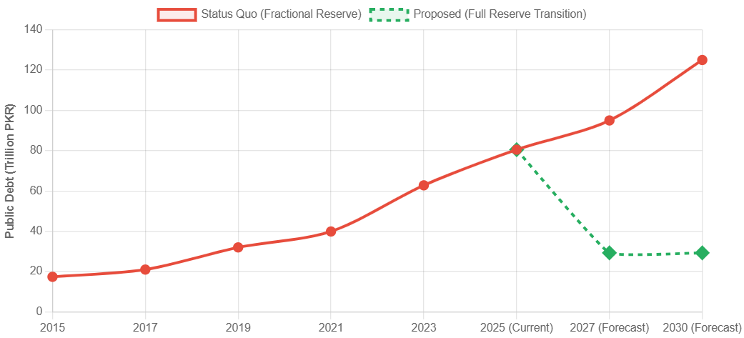
The theoretical implication here is dramatic: any policy intervention based on austerity or tax collection (fiscal policy) is bound to fail since it will be treating the symptom (the deficit) and not the cause (the interest-bearing nature of the money supply). The evidence of the simulation is that it is only a structural intervention, the so-called Asset Swap mechanism that is able to mathematically resolve the solvency crisis.
Seigniorage being a Public Right (and not a Privilege of the Privates)
One of the most important results of this work is the measure of forgone seigniorage. The potential annual revenue of around 4.8 Trillion through sovereign money creation challenges the economic dogma which asserts that governments have to finance their operations either by taxation or borrowing.
Islamically, theoretically, this observation is consistent with Chapra (1985) and Meera (2009) arguments. The analysis shows that the present regime of the FRB is a successful privatization of the good of the currency (seigniorage) and the evils (inflation and debt service) are socialized. A Full-Reserve system would enable the state to regain its right to Milkiyah (ownership) of the currency. Reclaiming of this revenue stream meets the Shariah goal of Adl (Justice) of making sure that the value created by the growing economy would be used by the common treasury and not by the shareholders of the bank.

Figure 2: The Fiscal Gap (Current Deficit vs. Proposed Surplus)

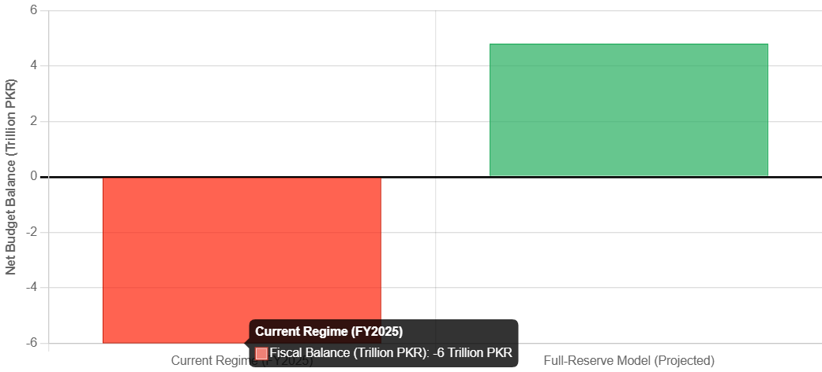
Implication to Inflation and Price Stability
As opposed to the critique in the Quantity Theory of Money, which dreads the issue of hyperinflation caused by money creation by the government, the simulation data suggests that a Full-Reserve system is more stable in terms of prices. The money supply under the current regime is growing according to the profitability of the commercial banks (credit demand), which explains the fluctuating inflation rates in the SBP data (4.6% - 25% variance).
The conceptual inference of the "Chicago Plan" simulation is that in any setting where money creation is unlinked with the issuance of debt, the central bank could pursue a steady-state rate of inflation of 0%. The reason is that the money supply would grow in relation with the amount of real goods and services and not increase exponentially to fund interest on loans made in the past. Such a change would radically transform the monetary policy framework of Pakistan and make this a regime of money-supply targeting rather than an interest-rate targeting regime, which is appropriate to the stability of an Islamic economy.
Limits of the Transition
It should be said that although the simulation tackles domestic insolvency, it does not explicitly liquidate the external debt of PRs. 29.3 Trillion. Nonetheless, the hypothetical model states that the resulting fiscal surplus (PRs. 12.36 Trillion/year) would create the required liquidity to buy foreign exchange and settle external liabilities at a faster rate, which is currently impossible with the debt-servicing burden.
Conclusion
The aim of this study was to examine the institutional causes of the fiscal insolvency in Pakistan and to determine the viability of a Full-Reserve Banking system that is based on Zakat as a corrective system. Combining historical data provided by the State Bank of Pakistan with the IMF econometric parameters of the so-called Chicago Plan, the research comes to the final conclusion: the existing Fractional-Reserve Banking system is not only inept, but is the major driver of the accumulation of debt in Pakistan.
In relation to first objective the research concludes that, the Government of Pakistan is literally losing around 1.236 Trillion money every year as a result of money supply privatization. This amount includes PRs. 7.56 Trillion of unjustified interest payments to local banks and 4.8 Trillion of lost seigniorage revenue. This expropriation is an enormous, systematic liquidation of the population coffers to the financial industry, which is a crime of the Islamic distributive justice (Adl).
In relation to second objective the simulation indicates that the introduction of a 100% reserve requirement would cause an instantaneous decrease in the national debt stock (by 63.6 percent or from PRs. 80.5 Trillion to PRs. 29.3 Trillion). Using a swap Deal or a so-called Debt-for-Reserves swap, the domestic debt item is nullified mathematically, which demonstrates the national solvency without foreign bailouts and the disabling austerity.
Policy Recommendations
Following these findings, the following structural reforms are recommended in this paper:
Legislative Amendment
The Parliament needs to make amendments to the State Bank of Pakistan Act in order to redefine Legal Tender. The authority to issue money should purely be limited to the State Bank and the commercial banks should be barred to issue deposits beyond their cash holdings.
Carrying out the Asset Swap
The Ministry of Finance and SBP are to embark on a transition phase wherein the T-Bills possessed by the commercial banks would be swapped to non-interest bearing SBP reserves, and be effectively monetized and cancelled in terms of the domestic debt.

Issuance of Asset-Backed Digital Currency
To keep the new money supply fundamentally stable, the SBP is to issue a Central Bank Digital Currency (CBDC) based on a basket of real assets (Gold, Strategic Resources) as opposed to a debt, matching the money to the real economy.
Finally, the economy that is Just cannot be constructed on a base of fictitious capital. The shift to Full-Reserve Banking is not a radical test, but a restoration of the sanity of the asset-based economics. To Pakistan, it is the only possible way in a chain of debt that it can be able to regain its economic independency.

References
Bank for International Settlements. (2024). The Bank of Amsterdam and the limits of fiat money (BIS Working Paper No. 1065). https://www.bis.org/publ/work1065.pdf
Benes, J., & Kumhof, M. (2012). The Chicago plan revisited (IMF Working Paper No. 12/202). International Monetary Fund. https://www.imf.org/en/Publications/WP/Issues/2016/12/31/The-Chicago-Plan-Revisited-26178
Chapra, M. U. (1985). Towards a just monetary system. The Islamic Foundation.
Choudhury, M. A. (2004). Money in Islam: A study in Islamic political economy. Routledge.
Dyson, B., & Jackson, A. (2013). Modernising money: Why our monetary system is broken and how it can be fixed. Positive Money.
Fisher, I. (1936). 100% money. Adelphi Company.
Friedman, M. (1960). A program for monetary stability. Fordham University Press.
Holloway, E. (1981). How Guernsey beat the bankers. Economic Reform Club.
Huber, J. (2017). Sovereign money: Beyond reserve banking. Palgrave Macmillan.
Institute of Policy Studies. (2024, March). IPS working group proposes full reserve banking model for Pakistan [Press release]. Islamabad.
Kahf, M. (1978). The Islamic economy: Analytical study of the functioning of the Islamic economic system. Muslim Students' Association of the United States and Canada.
Kotlikoff, L. J. (2010). Jimmy Stewart is dead: Ending the world's ongoing financial plague with limited purpose banking. John Wiley & Sons.
Meera, A. K. M., & Larbani, M. (2009). Ownership effects of fractional reserve banking: An Islamic perspective. Humanomics, 25(2), 101–116.
Ministry of Finance. (2024). Federal budget 2024-25: Budget in brief. Government of Pakistan. https://www.finance.gov.pk/budget/Budget_2024_25/Budget_in_Brief.pdf
Minsky, H. P. (1986). Stabilizing an unstable economy. Yale University Press.
Positive Money. (2016). Sovereign money: An introduction. Positive Money.
Siddiqi, M. N. (1983). Issues in Islamic banking. The Islamic Foundation.
State Bank of Pakistan. (2025). The state of Pakistan's economy: Annual report 2024-2025. State Bank of Pakistan.
Turner, A. (2015). Between debt and the devil: Money, credit, and fixing global finance. Princeton University Press.
Usmani, M. T. (1999). The historic judgment on interest. Idaratul Ma'arif.
Werner, R. A. (2014). Can banks individually create money out of nothing? The theories and the empirical evidence. International Review of Financial Analysis, 36, 1–19.
Zaman, A. (2015). Creation of money and Islamic banks. Journal of Islamic Business and Management, 5(2).
Zaman, A. (2016). The crisis of capitalism and the Islamic alternative. Journal of King Abdulaziz University: Islamic Economics, 29(1).

Appendix
The following primary sources were utilized to extract the fiscal variables and simulation parameters for this study. Direct links are also provided here;
Source A: Fiscal Data (Debt & Interest) of Pakistan
- Document
Federal Budget 2024-25: Budget in Brief / Annual Budget Statement
- Publisher
Ministry of Finance, Government of Pakistan
- Data Point Verification
Total Tax Revenue Target. PRs. 12.97 Trillion (Page 2, Table 1)
Debt Servicing Estimate. PRs. 9.7 Trillion (Revised to 8.9T in SBP projections) (Page 13, Table 3)
- Direct Link
Finance Division - Budget in Brief 2024-25 (PDF)
Source B: The "Chicago Plan" Simulation Model
- Document
The Chicago Plan Revisited (IMF Working Paper 12/202)
- Publisher
International Monetary Fund (IMF) Research Department
- Data Point Verification
Reduction in Public Debt. ~100% (Net) (Page 56, Table 2)
Inflation Steady State. 0% (Page 62, Figure 5)
- Direct Link
IMF Library - WP/12/202 (PDF)
Source C: Bank of Amsterdam Historical Data
- Document
The Bank of Amsterdam and the limits of fiat money (BIS Working Paper No 1065)
- Publisher
Bank for International Settlements (BIS)
- Data Point Verification
Success of 100% backing in maintaining guilder stability (1609-1780s).
- Direct Link
BIS Publications - Work1065 (PDF)

