Ayesha Noureen
PRIZE Article writing competition
31/12/2025

Title : Zakat Based Interest Free Economy
Introduction
An economy is how money is earned and shared in society. Today, most economies run on interest (Riba), which causes poverty, debt, and injustice. Islam offers a better, fair, and balanced system based on Zakat.
What Is Zakat?
Zakat is a mandatory charity in Islam and one of the five pillars. Allah commands Muslims to give Zakat.
“And establish prayer and give Zakat.” (Surah Al-Baqarah 2:43)
Importance of Zakat
Zakat cleans wealth, helps the poor, builds a strong society, and is not optional. It is the right of the poor.
Who Receives Zakat?
Allah has defined Zakat recipients:
“Zakat is for the poor, the needy, those employed to collect it, those whose hearts are to be reconciled, freeing slaves, those in debt, in the cause of Allah, and for the traveler.” (Surah At-Tawbah 9:60)
This makes Zakat a complete welfare system.
■Interest-Free Economy:
An interest-free economy has no interest or unfair gain.
“Allah has permitted trade and forbidden interest.” (Surah Al-Baqarah 2:275)
■Harm of Interest:
Interest benefits the rich without effort and increases debt for the poor.
“O you who believe! Fear Allah and give up what remains of interest.” (Surah Al-Baqarah 2:278)
The Prophet ﷺ said:
“Allah has cursed the one who consumes interest, the one who gives it, the one who writes it down, and the witnesses to it.” (Sahih Muslim)
■Zakat and Poverty Reduction
Zakat provides food, clothes, medicine, and education.
“And in their wealth there is a known right for the needy and the poor.” (Surah Al-Ma’arij 70:24–25)
■Zakat and Debt Relief
Zakat reduces hardship and prevents people from taking interest-based loans.
“Whoever relieves a believer’s hardship, Allah will relieve his hardship on the Day of Judgment.” (Sahih Muslim)
■Stopping Hoarding:
Islam discourages hoarding wealth.
“Those who hoard gold and silver and do not spend it in the way of Allah—give them tidings of a painful punishment.” (Surah At-Tawbah 9:34)
■Social Justice:
Zakat reduces the gap between rich and poor.
“So that wealth may not circulate only among the rich from among you.” (Surah Al-Hashr 59:7)
■Zakat and Debt Relief:
Zakat reduces hardship and prevents people from taking interest-based loans.
“Whoever relieves a believer’s hardship, Allah will relieve his hardship on the Day of Judgment.” (Sahih Muslim)
■Stopping Hoarding:
Islam discourages hoarding wealth.
“Those who hoard gold and silver and do not spend it in the way of Allah—give them tidings of a painful punishment.” (Surah At-Tawbah 9:34)
■Social Justice:
Zakat reduces the gap between rich and poor.
“So that wealth may not circulate only among the rich from among you.” (Surah Al-Hashr 59:7)
■Self-Reliance:
Zakat helps people become independent.
“The upper hand is better than the lower hand.” (Bukhari & Muslim)
■Role of Islamic State:
The Islamic government must collect and distribute Zakat fairly.
“The Imam is a guardian and responsible for his people.” (Sahih Bukhari)
Moral Benefits:
Zakat promotes kindness, sharing, and brotherhood.
“He is not a believer whose stomach is filled while his neighbor goes hungry.” (Musnad Ahmad)
Zakat vs Interest System:
Interest system is greed-based and increases poverty.
Zakat system is mercy-based and improves society.

Table 1
Zakat Calculation for Different Assets
The standard rate of 2.5% applies to a wide range of assets, provided the total wealth meets the Nisab threshold and has been owned for a full lunar year.

Asset type | Zakat Rate | Basis for Calculations
Cash in Hand/Bank | 2.5% | Total cash balance in all accounts
Gold and Silver | 2.5% | The current market value/weight.
Investments /shares | 2.5% | Current market value of stocks, bonds, or mutual funds.
Business/Trade Goods | 2.5% | Value of all saleable stock-in-trade (after deducting liabilities).
Loans Receivable | 2.5% | Cash lent to others that is expected to be returned.
Agricultural Produce | 2.5% | Varies by irrigation method (e.g., 5% for irrigated land, 10% for rain-fed).
Livestock | Specific Quantities | Nisab is 30 for cattle/bovine, 40 for sheep/goats, and 5 for camels.
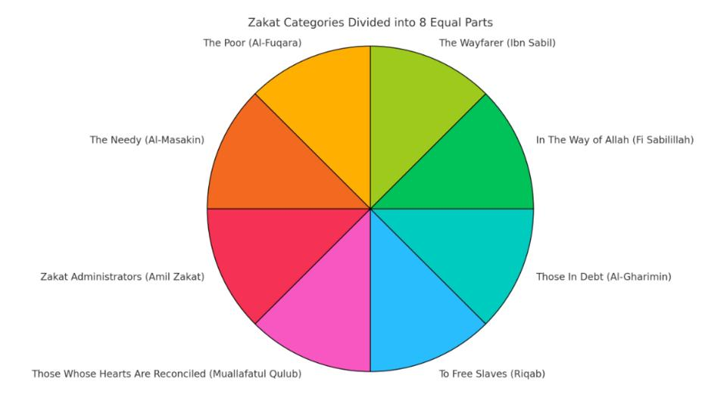
Fig. 1. Zakat spending as per the Quran on 8 categories of people

Role of Zakat in Poverty Alleviation:
Poverty is one of the major challenges in both developing and developed countries.
Zakat directly addresses this issue by providing financial assistance to those who lack basic necessities such as food, shelter, education, and healthcare.
Unlike interest-based loans, Zakat:
▪︎Does not burden recipients with repayment
▪︎Preserves dignity and self-respect
▪︎Offers long-term relief rather than temporary fixes

Modern Solutions and Policy Recommendations:
▪︎To strengthen a Zakat-based interest-free economy, the following steps are essential:
▪︎Establish transparent and regulated Zakat authorities
▪︎Use digital platforms for collection and distribution
▪︎Integrate Zakat with national poverty alleviation programs
▪︎Promote awareness and education on economic role of Zakat

Conclusion :
Zakat is a powerful economic institution that forms the backbone of an interest-free economy. By redistributing wealth, alleviating poverty, reducing debt, discouraging hoarding, and promoting social justice, Zakat addresses many of the shortcomings of interest-based systems.
In an era marked by financial crises and growing inequality, the Zakat-based economic model offers a sustainable, ethical, and human-centered alternative. With proper institutional support and modern management, Zakat can contribute significantly to building a just and stable economic system free from interest and exploitation.

Reference: Quran Pak; Ahadis( Sahih Bukhari;Sahih Muslim ) ;
Google.

