The Zakat Based Interest free Economy
(Reforming Money and Banking)
The Predatory Nature of Modern Banking:
The contemporary global financial landscape is increasingly characterized by what the Netflix Original Series "Dirty Money" exposes: a system built on exploitation and predatory lending. This "Debt-Trap" is not accidental but a structural outcome of fractional reserve banking. Economists like Patrick Honohan have documented how financial depth, when driven by interest-based debt rather than productive equity, leads to systemic fragility. For Pakistan, this system has resulted in a cycle of perpetual borrowing where the national wealth is drained to service interest (Riba), leaving the populace in a state of economic subservience. To break this cycle, we must move beyond the "Dirty Money" model toward a system that prioritizes ethical circulation over debt creation.
The Mechanics of Money Creation vs. Sovereign Control:
Modern banking operates on a principle called Fractional Reserve Banking. As highlighted in the research of Richard Werner and the IMF’s "Chicago Plan Revisited x commercial banks do not simply lend out existing deposits. Instead, they create "new money" every time they issue a loan. This is essentially "Money Creation out of Nothing."
When a bank approves a loan, it credits the borrower's account with a digital entry. This increases the total money supply in the country. However, because this money is born out of Debt, it carries an interest (Riba) burden. This is the "Dirty Money" cycle: for every rupee created, more than a rupee must be paid back. Since the extra money to pay the interest was never created, the system forces someone, somewhere, to go bankrupt. This is the "Debt Trap" that Patrick Honohan warns about a system that is mathematically designed to fail the masses.
The Divine Allocation of Wealth
Under Shariah law, Zakat is not a discretionary fund; it is strictly reserved for eight specific categories (Masarif) as outlined in the Holy Quran (Surah At-Tawbah, 60). These include:
1.Al-Fuqara: The poor who have no income.
2.Al-Masakin: Those whose income does not meet their basic needs.
3.Al-Amilina 'Alayha: The administrators appointed to collect and distribute Zakat.
4.Al-Mu'allafatu Qulubuhum: To reconcile hearts (social harmony and support).
5.Fir-Riqab: For freeing those in bondage or debt-slavery.
6. Al-Gharimin: For those burdened by overwhelming debt.
7.Fi-Sabilillah: For those striving in the cause of Allah (education, welfare, defense).
8. Ibnus-Sabil: For the stranded traveler
The legal mendate and shariya framework:
The transition toward an interest-free economy is no longer a choice but a legal mandate. The Federal Shariat Court (FSC) of Pakistan, in its landmark 2022 Judgment, declared that Riba is absolutely prohibited in all its forms, including banking interest. This judgment is the culmination of decades of advocacy by scholars like Mufti Taqi Usmani.
Mufti Taqi Usmani’s vision, as articulated in his role in the Supreme Court’s Shariat Appellate Bench, is that a Riba-free system is essential for social justice. He argues that interest-based banking concentrates wealth in the hands of the 1% (the elite), while the 99% bear the risk. The State Bank of Pakistan (SBP) is now tasked with implementing this vision. According to the SBP’s Strategic Plan, the transformation involves converting conventional banks into "Full-fledged Islamic Banks," moving away from the "Money out of Nothing" model to an asset-backed model where every transaction is linked to a real economic activity (trade, manufacturing, or services).
100 %Reserve Banking :
To fully implement the Shariah mandate, Pakistan must transition toward 100% Reserve Banking. Unlike the current fractional reserve system where banks create 'debt-money' out of thin air a 100% reserve requirement ensures that every rupee in the banking system is backed by real assets. This was a core proposal in the IMF’s Chicago Plan Revisited and is the only mathematical way to permanently decouple the national money supply from interest-based
The Science of Zakat and the Multiplier Effect:
The Zakat-driven model is a scientific alternative to interest-based stagnation. Unlike the current system where money hoarding is incentivized, Zakat acts as a tax on idle capital, forcing it into the economy. When Zakat is distributed across the 8 Masarif (eligible categories), it triggers a powerful Economic Multiplier Effect. By putting purchasing power into the hands of the marginalized, it increases the "Velocity of Money" the speed at which currency circulates to create trade and jobs. This transformation effectively replaces "money creation through debt" (as criticized by Richard Werner and the IMF’s Chicago Plan) with "wealth distribution through justice," ensuring that the 3rd largest youth population of Pakistan becomes an economic asset rather than a liabili.
Ushr and Agricultural Stability:
Pakistan’s economic backbone is its agricultural sector, and the implementation of Ushr is the primary tool for rural poverty alleviation. Under Shariah law, Ushr is a mandatory levy on land produce 10% on rain-fed (Barani) land and 5% on artificially irrigated land. Unlike conventional land taxes that burden the farmer regardless of yield, Ushr is only due on actual production, making it a fair and flexible system.
By systematically collecting Ushr, the state can create a localized fund dedicated to providing farmers with high-quality seeds, fertilizers, and modern machinery. This eliminates the need for interest-based agricultural loans that often lead to "Debt-Traps" for small-scale farmers. Furthermore, Ushr ensures food security by discouraging the hoarding of essential crops, as the act of giving ensures a continuous flow of supply into the market, stabilizing prices for the general public.

Zakat as a Sovereign Fiscal Tool :
Zakat and Ushr are not merely charitable acts; they function as powerful Sovereign Fiscal Tools for national economic management. Unlike conventional taxes that often burden production, Zakat targets idle wealth, effectively penalizing the hoarding of capital.
Wealth Redistribution: As a fiscal tool, Zakat creates a mandatory flow of liquidity from the surplus-holding elite to the deficit-facing poor, ensuring that money remains in circulation.
Economic Stabilizer: Ushr serves as an "Automatic Stabilizer" in the agricultural sector; the contribution fluctuates naturally with the harvest yield, protecting farmers during low-production years while maximizing state resources during bumper crops.
Debt Reduction: By utilizing this indigenous fiscal mechanism, the State Bank of Pakistan can fund social safety nets independently, reducing the national reliance on high-interest international loans and breaking the "Dirty Money" debt cycle.
The Norwegian Model & Zakat:
To understand the potential of a national fund, we can look at Norway’s Sovereign Wealth Fund. Norway transformed its economy by ensuring that its oil wealth was managed transparently for the collective benefit of all citizens, rather than a few elites.
Similarly, if Pakistan implements Zakat and Ushr as a transparent national fund, it can function as our own 'Sovereign Fund.' By moving wealth from idle bank accounts (Dirty Money) into productive social sectors (The 8 Masarif), Pakistan can achieve the same level of social security and financial independence seen in Scandinavia. This shift ensures that national resources are used to empower the public, breaking the cycle of international debt."
The Moral Challenge: Confronting the Gatekeepers of Riba:
The transition to an interest-free, Zakat-based economy is not merely a technical shift but a profound moral struggle. The primary resistance comes from the entrenched elite and the banking cartels who have long benefited from the "Dirty Money" cycle and the exploitation of the poor. For a banking system addicted to the risk-free profits of Riba, and an elite class that views wealth through the lens of ego rather than stewardship, this reform is a threat to their hegemony. They often forget that Zakat is not a loss of wealth but a purification that ensures the "Key Chain" of the economy functions smoothly.
When wealth circulates through the 8 Masarif, it eliminates social crimes and economic oppression, creating a society where no one is left behind. The government must realize that its current injustice is unsustainable. While the wealthy may fear the loss of millions in Zakat, they fail to see that a stable, crime-free, and prosperous society is the only way to protect their own future. We must provoke this change through persistent intellectual Jihad, reminding the powerful of their history and their eventual mortality. Only when we replace greed with "Adl" (Justice) can we build an economy that serves humanity instead of enslaving it.

Our Vision for a Sovereign Economic Framework:
Our vision is a total transition of Pakistan’s financial architecture from a debt-based, inflationary model to an equity-based system that replaces "Dirty Money" with sovereign, asset-backed currency. This change is vital because the current interest-based system creates a predatory cycle where debt-servicing drains national wealth. We will achieve this through the Federal Shariat Court’s 2022 mandate, moving toward 100% Reserve Banking, and utilizing Zakat and Ushr as primary fiscal tools. This collective effort ensures wealth circulates through the 8 Masarif, transforming Pakistan into a debt-free leader of the global Islamic economy.
The Great Transition: Replacing the Riba Epidemic with a Divine Economic Sovereign
The Vaccine: Dismantling Riba Monopoly
The Virus: Modern banking is a systemic epidemic, poisoning society through "phantom wealth" and debt.
The Vaccine: We must deploy an Economic Vaccine by shifting from debt-based digits to Asset-Backed Currency.
Building Immunity: Grassroots Interest-Free Trade Circles create social immunity against exploitative banking monopolies.
Circulation: While Riba causes wealth to "clot," Zakat ensures vital circulation to heal the economic body.
The Result: This vaccine dismantles the rigged system, restoring national sovereignty and divine economic balance
The Blueprint: Digital Shariah Governance
To move beyond theoretical models, Pakistan requires a Digital Shariah Infrastructure. Unlike existing social safety nets such as BISP or conventional subsidy programs that often suffer from middle-man leakages and centralized data manipulation, this model relies on Blockchain-enabled Zakat Portals. This secure, decentralized digital ledger prevents record tampering, ensuring real-time tracking of the eight Masarif with absolute transparency.
By integrating Quranic distributive justice with modern FinTech, we eliminate the corruption often seen in manual distribution. Funds reach verified beneficiaries directly via decentralized IDs, preventing "ghost" entries or agent deductions. This blueprint transforms Zakat from static charity into a dynamic, technology-driven engine. It ensures wealth does not just provide temporary survival, but creates a high-velocity economic cycle that empowers the recipient to eventually become a contributor, stabilizing Pakistan’s economy through divine accountability
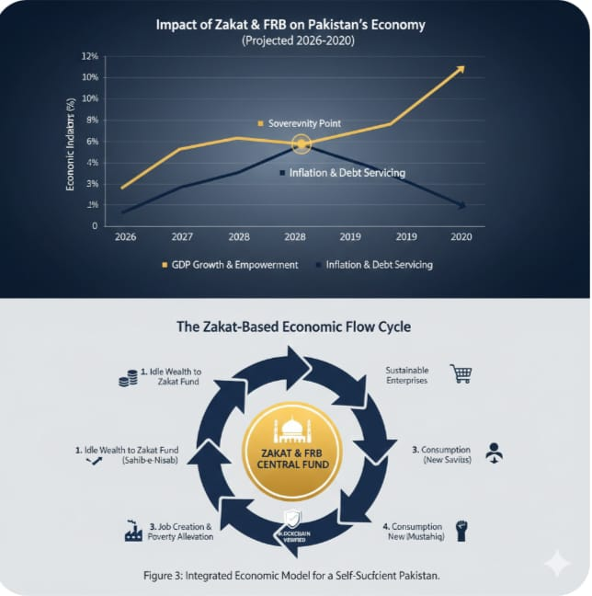

Conclusion :(The Sovereign Awakening)
Beyond any doubt, Pakistan’s survival lies in building an economic immune system through Shariah compliant finance. By replacing the "virus" of Fractional Reserve banking with a 100% Reserve model, we neutralize the root causes of inflation. This transition is not a distant dream but a practical Economic Vaccine that restores our national health and sovereignty. We must remember that hope is always better than desperation; a transparent, Zakat-driven framework ensures a self-sufficient future where justice replaces debt. This is the mirror of truth: a Pakistan thriving on divine balance, resilient against global financial epidemics.

s

References
1:Federal Shariat Court of Pakistan (2022). Judgment on Riba (Interest-free Economy).
2: Honohan, P. (2004). Financial Development, Growth and Poverty. World Bank Policy Research.
3:Usmani, M. T. (2002). An Introduction to Islamic Finance. Maktaba Ma'ariful Qur'an.
4:Benes, J., & Kumhof, M. (2012). The Chicago Plan Revisited. IMF Working Paper.
5:State Bank of Pakistan. Strategic Plan for Islamic Banking Industry.
6:Netflix Original Series. (2018). Dirty Money.
7: Bareera Tabasum , (2025) Personal Reflection and Synthesis : The Socio - Economic Impact of Zakat and the Moral Crisis of Modern Banking.

Name: Bareera Tabasum
Riphah International University (Gulberg campus )
hpurple789@gmail.com

