ENDING EXPLOITATIVE TAXATION:

A Zakat based system for Justice, Economic Growth and Welfare for All:
Muneeba Saeed
Abstract:
After witnessing extreme exploitation, corruption and unprecedented taxation the need of Islamic based Economic system has skyrocketed. With billions of people thrusted into poverty through indirect taxation merely benefiting the wealthy class. It is need of the hour to focus on eliminating this difference to create an inclusive system working to uplift the whole community in general. This article focuses on zakat system, its distribution in Islamic context and devises a plan in chronological order to formulate an Islamic based Economic System. The world is divided into two school of thoughts with many in favour of zakat application and others against the idea considering it the originator of unproductivity. While the system may seem complex at first with the help of this article many doubts regarding the system can be effaced.
Key Words: Regressive Taxation, Tax Burden, Deadweight Loss, Redistribution, Targeted Transfers, Inclusive Growth, Marginal Propensity to Consume(MPC).
Introduction:
In Islamic economic thought, Zakat is not merely a charitable act but a systemic economic institution designed to end inequality, redistribute wealth fairly, and eliminate exploitative forms of taxation. The literal, or denotative, definition of the word zakat (sometimes spelled zakah) is “increase,” as in growth (nama). The word also connotes “betterment” (tahsun), “righteousness” (salah), “praise” (hamd), “blessings” (barakah), “purification” (taharah). This indicates that zakat is not just merely focused on redistribution of wealth but also pays heed to the upliftment or growth of society. Zakat is primarily intended to alleviate poverty and create a self-reliant Muslim community, one in which economic development, education, human resource, empowerment and health services are equitably accessible to all.
Zakat based system ensures that the burden of revenue generation does not fall on the poor through oppressive taxation, hidden charges or exploitative taxation. It acts as a check and balance system ensuring the welfare of the community, taking from those with surplus income to redistribute it equally in the society. This aids in creating a community rooted in compassion, accountability and human dignity.
Zakat promotes long-term growth by not merely providing basic facilities to the struggling class but by empowering recipients until they become strong enough to continue the cycle and join the ranks of Zakat payers themselves.
One incident that highlights this point is reported by Anas Ibn Malik:
A man from the Ansar came to the prophet (PBUH) and begged from him. The
Prophet said “Have you nothing in your house?” The man said, “Yes, a piece of cloth, a part of which we
wear and a part of which we spread on the ground, and a wooden bowl from which we drink water”.
Anas Ibn Malik reported: “A man from the Ansar came to the prophet (PBUH) and begged from him. The
Prophet said “Have you nothing in your house?” The man said, “Yes, a piece of cloth, a part of which we
wear and a part of which we spread on the ground, and a wooden bowl from which we drink water”. The
prophet said “Bring them to me”. The Man brought these articles to him and the prophet took them in his
hands and he said “Who will buy these?” someone said “I will buy them for one coin”. The Prophet said
twice or thrice, “Who will offer more?” Someone said, “I will buy for two coins”. He sold them for two coins
and the Prophet said “Buy food with one of them and give to your family. An axe and bring it to
me………” An axe was fixed and a man was directed to fetch and sell firewood to make a living which he did.
The above Hadith indicates that, the man was able-bodied, strong enough to do the job as advised by the
Prophet but was determined to live off begging. Zakat could have been available or otherwise, but the choice
to acquire a tool (an axe) provided a long term solution.
Anas Ibn Malik reported: “A man from the Ansar came to the prophet (PBUH) and begged from him. The
Prophet said “Have you nothing in your house?” The man said, “Yes, a piece of cloth, a part of which we
wear and a part of which we spread on the ground, and a wooden bowl from which we drink water”. The
prophet said “Bring them to me”. The Man brought these articles to him and the prophet took them in his
hands and he said “Who will buy these?” someone said “I will buy them for one coin”. The Prophet said
twice or thrice, “Who will offer more?” Someone said, “I will buy for two coins”. He sold them for two coins
and the Prophet said “Buy food with one of them and give to your family. An axe and bring it to
me………” An axe was fixed and a man was directed to fetch and sell firewood to make a living which he did.
The above Hadith indicates that, the man was able-bodied, strong enough to do the job as advised by the
Prophet but was determined to live off begging. Zakat could have been available or otherwise, but the choice
to acquire a tool (an axe) provided a long term solution.
Anas Ibn Malik reported: “A man from the Ansar came to the prophet (PBUH) and begged from him. The
Prophet said “Have you nothing in your house?” The man said, “Yes, a piece of cloth, a part of which we
wear and a part of which we spread on the ground, and a wooden bowl from which we drink water”. The
prophet said “Bring them to me”. The Man brought these articles to him and the prophet took them in his
hands and he said “Who will buy these?” someone said “I will buy them for one coin”. The Prophet said
twice or thrice, “Who will offer more?” Someone said, “I will buy for two coins”. He sold them for two coins
and the Prophet said “Buy food with one of them and give to your family. An axe and bring it to
me………” An axe was fixed and a man was directed to fetch and sell firewood to make a living which he did.
The above Hadith indicates that, the man was able-bodied, strong enough to do the job as advised by the
Prophet but was determined to live off begging. Zakat could have been available or otherwise, but the choice
to acquire a tool (an axe) provided a long term solution.
Anas Ibn Malik reported: “A man from the Ansar came to the prophet (PBUH) and begged from him. The
Prophet said “Have you nothing in your house?” The man said, “Yes, a piece of cloth, a part of which we
wear and a part of which we spread on the ground, and a wooden bowl from which we drink water”. The
prophet said “Bring them to me”. The Man brought these articles to him and the prophet took them in his
hands and he said “Who will buy these?” someone said “I will buy them for one coin”. The Prophet said
twice or thrice, “Who will offer more?” Someone said, “I will buy for two coins”. He sold them for two coins
and the Prophet said “Buy food with one of them and give to your family. An axe and bring it to
me………” An axe was fixed and a man was directed to fetch and sell firewood to make a living which he did.
The above Hadith indicates that, the man was able-bodied, strong enough to do the job as advised by the
Prophet but was determined to live off begging. Zakat could have been available or otherwise, but the choice
to acquire a tool (an axe) provided a long term solution.
A man from the ansar came to the prophet PBUH and begged from him. The prophet said “Have you nothing in your house” The man said,” Yes, a piece of cloth, a part of which we wear and a part of which we spread on the ground, and a wooden bowl from which we drink water.” The prophet said “Bring them to me.” The man brought these articles to him and the prophet took them in his hands and he said “Who will buy these.” someone said “I will buy them for one coin.” The prophet said twice or thrice, ”Who will offer more?” someone said “I will buy for two coins.” He sold them for two coins and the prophet said “Buy food with one of them and give to your family. An axe and bring it to me….” An axe was fetched and the man was directed to fetch and sell firewood and a living which he did.
This hadith indicates that the man was able-bodied and chose begging which was discouraged by the Prophet. Instead he devised a solution that tackled the problem offering a long-term solution and encouraging productivity over laziness.
Following the rulings and hadith of the prophet and the working of Riyasat-e-Madīnah (first Islamic welfare state) a system can be formulated that works in modern day time and is collectively benefiting the society while following the obligations of Islam.
METHODOLOGY:
The study is designed to identify the problem in current regressive and exploitative taxation that is causing damage to Pakistan’s economy benefiting the elites while suppressing the low paid under heavy burdens of taxation. Moreover it showcases the incompetency of the current system highlighting its low revenue generation, insufficient GDP and spread of inflation even after collection of heavy taxes. Similarly it emphasizes on the cause of low MPC (Marginal Propensity to consume) and its effect on GDP and how zakat solves this issue and gives money to high MPC people benefiting the overall economy. Through thorough explanation of multiple research and publication this study helps to devise a system resulting in favor of community while preserving the essence of islam.
Discussion:
Exploitative Taxation: The Problem:
One of the major problems faced by Pakistan Economic System is indirect taxation, which although seems profitable is one of the major cause of low revenue generation. It’s important to understand that those with surplus income have low MPC and high MPS value which is beneficial solely to them. As they have low consumption rate and are more focused on hoarding while paying the equal amount of tax as a low income generator they are able to accumulate wealth. While the large portion of income dependent people become poor day by day resulting in less consumption of goods and high inflation.
This not only effects the economy but also instills inequality and hatred resulting in crimes, theft and in general disturbs the equilibrium causing threat to the stability of the society. Although the Government imposes taxes to benefit the GDP due to its incorrect application it causes more damage then welfare. Through indirect taxation government is able to accumulate 5.5% GDP which is extremely less in comparison to its spending.
Zakat in Islamic Economic System:
Zakat is a holistic system which not just benefits the struggling class but also uplifts it aiding in growth instead of mere help. Zakat literal meaning is growth and purification, which signifies that the recipient is not meant to remain dependent on Zakat for financial survival. Instead, through systematic redistribution of surplus wealth, Zakat enables individuals to become economically stable, self-reliant, and eventually part of the contributing and paying segment of society. Thus, Zakat functions as a mechanism of empowerment, ensuring social mobility and sustainable economic development.
The Prophet ﷺ said:
“The best charity is that which leaves the recipient self-sufficient.”
(Sunan Abū Dāwūd, Hadith 1677 — Hasan)
Zakat basic purpose is uplifting the society ang giving back so a world is created where survival of every community is possible and feasible.
Distribution of Zakat for Justice and welfare:
Zakat, a mandatory Islamic charity, is distributed among eight specific categories (asnaf) defined in the Quran (9:60): the poor (Fakir), the needy (Miskin), Zakat administrators (Amil), new converts (Muallaf), those in bondage (Riqab), debtors (Gharimin), those in Allah's cause (Fi Sabilillah), and stranded travelers (Ibn Sabil).
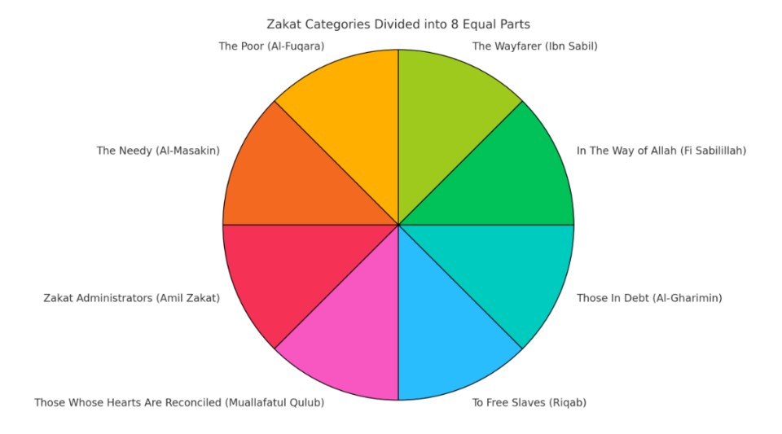
This ayah showcases that zakat distribution is not done randomly but with the purpose of uplifting the class genuinely in need of help. The targeted transfer ensures that the distribution is done evenly and rightly reaching rightful recipients generating tangible outcome instead of rhetorical or pseudo-political promises.
It ensure that tax is much simpler and corruption free since its intended for the poor and obligated by Allah (S.W.T).
The Prophet ﷺ said:
“Whoever strives to provide for a widow or a poor person is like one who strives in the cause of Allah.”
(Ṣaḥīḥ al-Bukhārī, Hadith 6006)
Link to growth:
This Hadith supports the idea that helping the poor is not charity alone but a productive economic investment in society.
Economic Impacts of a Zakat-Based System:
Over the years, the spending rate has decreased as wealth keeps accumulating among the rich, which has resulted in higher prices and slow consumption. Rich people usually have a lower MPC, which directly affects the economy. The effects of this are mostly faced by the struggling class. Due to stagnant salaries and rising needs, there is very little room left for consumption or savings. When demands are not fulfilled, this economic pressure often leads to frustration, protests, and social unrest. This causes political instability and unrest. It also breeds hatred among masses fueling crimes and inequality. To eliminte this pattern Islam introduced zakat to balance wealth in society. Zakat functions as a perfect balancing tool by redistributing the surplus wealth from the rich to the poor. Since higher income group have a lower Marginal Propensity to Consume the accumulation of wealth causes slowdown in economic activity. Zakat directly tackles this problem by distributing the wealth among struggling class with higher MPC, thereby increasing consumption, stimulating demand and promoting economic circulation. Prophet (P.B.U.H) emphasized on redistribution of wealth. In one of the hadith it is stated that:
“Allah has obligated charity upon their wealth, to be taken from their rich and given to their poor.”
(Ṣaḥīḥ al-Bukhārī, Hadith 1395; Ṣaḥīḥ Muslim)
Riyasat-e-Madinah: The Model State:
Riyasat-e-Madinah represents the first practical implementation of an Islamic state under Prophet (P.B.U.H), founded on the principles of justice, equality, and collective welfare. Unlike modern welfare states that rely on coercive and often exploitative taxation, the state of Maadina was founded upon divinely guided economic obligations such as Zakat, ensuring moral responsibility alongside economic balance. Zakat was established as a compulsory public levy, collected and distributed by the state through the Bayt-ul-Māl. The Prophet Muhammad ﷺ appointed officials for Zakat collection and strictly prohibited its misuse, ensuring transparency and justice. This system effectively reduced poverty, maintained consumption, and prevented excessive accumulation of wealth in a few hands. The state prioritized human dignity, social harmony, and fair distribution of resources, creating a system where wealth circulation was encouraged rather than accumulation. This caused tranquility and balance among muslims igniting the feelings of brotherhood and eliminating differences. The practical importance of Zakat became even clearer after the death of the Prophet ﷺ, when some tribes refused to pay Zakat, claiming it was no longer obligatory. Hazrat Abu Bakr (RA) firmly rejected this stance and declared war against the Zakat violators (Ahl al-Ridda), stating:
“By Allah, I will fight those who differentiate between prayer and Zakat.”
This event highlights that Zakat was not viewed as voluntary charity but as a state-enforced economic obligation, essential for maintaining social and economic balance. Abu Bakr’s action ensured continuity of the welfare system and prevented economic fragmentation. Zakat thus became the backbone of Islamic Economy due to its mandatory, targeted and poverty-eliminating nature.
Policy Recommendations for Implementation:
The main cause of separation was the incapability to follow Islamic rules under the dominance of Indian monoistic thoughts, which favored blending cultures while completely dominating political arena, leaving no room for other inhabitants. Pakistan was founded on the teachings of Qur’an and Sunnah, with Muslims preaching that Islamic Principles be the core foundation. It is no surprise that the taxation system follows Western models, which have become a major reason for class discrimination and social scrutiny. Even Allama Iqbal critically examined the system and highlighted the division it caused:
اپنی ملت پر قياس اقوام مغرب سے نہ کر
خاص ہے ترکيب ميں قوم رسول ہاشمی
ان کی جمعيت کا ہے ملک و نسب پر انحصار
قوت مذہب سے مستحکم ہے جمعيت تری
دامن ديں ہاتھ سے چھوٹا تو جمعيت کہاں
اور جمعيت ہوئی رخصت تو ملت بھی گئی

One point that becomes crystal clear from this verse is that if we follow the western ideas and modules blindly we will not only be divided in groups but also experience waves of hatred enveloping us. It is the need of the hour to return to our roots and for that a systemized change is needed. The taxation system, currently modeled on Western structures that perpetuate class inequality, should be replaced or supplemented with an Islamic Zakat-based framework. This framework would ensure equitable wealth redistribution, reduction of poverty, and economic empowerment for all citizens, fostering social harmony and aligning with the moral and economic vision upon which Pakistan was founded. Instead of rushing into the adoption of Zakat based system it is essential to first instill its concept and create an environment where the system becomes familiar and socially accepted.
One of the initial steps can be Centralized collection and digital tracking, In today’s world, where governance increasingly relies on technology and data-driven systems, traditional manual methods have become inefficient in official settings. However, Zakat is still largely collected through provincial or local personnel who depend heavily on manpower for both collection and distribution, leading to delays, leakages, and inefficiency. One of the major reasons for this structure is the lack of public trust in the central government, which many citizens perceive as incompetent or corrupt, further weakening the effectiveness of centralized welfare mechanisms. While public trust cannot be restored overnight, it can gradually be rebuilt through meaningful collaboration with provincial governments and the implementation of transparent, accountable, and results-oriented measures. Pakistan currently has over 46% of rural households and 18% of urban households living below the poverty line, according to research conducted by Naveed and Ali (2012). Addressing this challenge requires systematic data collection on vulnerable families and the formulation of targeted strategies to integrate these populations into the productive workforce. Providing these populations with a sense of purpose and access to essential resources is vital for societal uplift. Moreover, investing in their education and equipping them with relevant skills can not only enhance individual livelihoods but also address existing labor shortages by integrating marginalized groups into the workforce. To achieve this objective, the central government must establish a professional and independent body responsible for collecting accurate, need-based data essential for workforce planning and social integration. This mechanism would also enable the transparent and targeted allocation of Zakat revenues to the areas of greatest need. The persistent diversion and mismanagement of Zakat funds before their investment in productive ventures is not a hidden flaw but a structural failure that continues to erode public trust and weaken the impact of welfare initiatives. Strong evaluation and assessments should be employed by zakat distribution agents. Capacity and work capability should be examined. A strategic and balanced distribution program needs to be developed that allocates zakat in different sectors without over funding one sector to create balanced improvements.
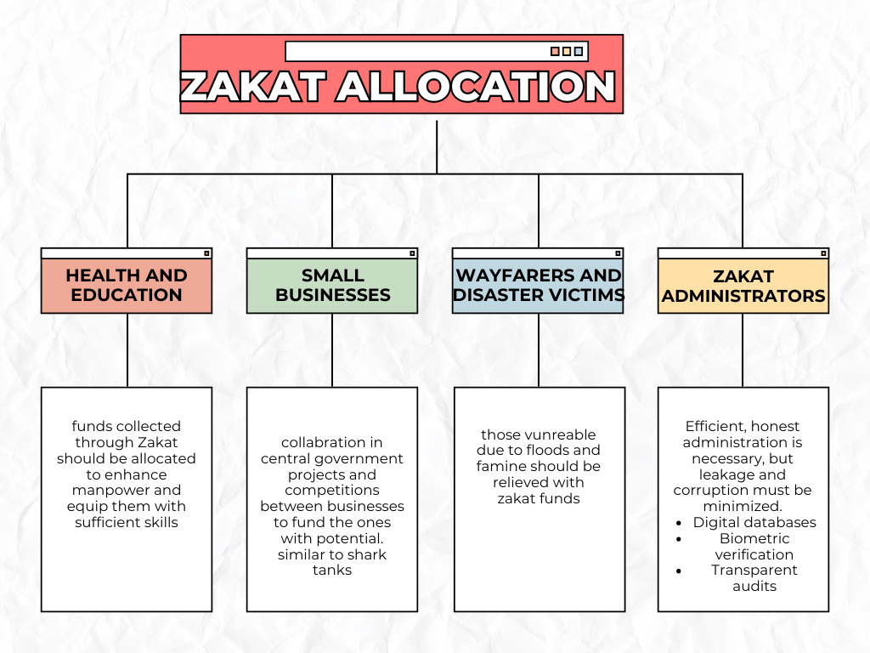
While countering the problem of zakat allocation an area worth focusing is Empowering recipients to generate income (self-sufficiency). It is necessary for the government to invest in manpower. Study conducted by Naveed and Ali shows that Expenditure spend on Education and Health is not even 5% of GDP in Pakistan. Due to such low expenditure spent on developing human capital and maintaining health of the masses, poor people remain uneducated and unhealthy finding it difficult to get out of poverty trap. It is undeniable that the only reason of difference between the poor and the wealthy is the education they receive. China’s focus was mainly on training the masses about the new machinery, educating and equipping them with necessary skills for operating the factories before industrial revolution. This example clarifies that without education self-sufficiency is impossible highlighting the urgent need to focus on this sector. With the funds received through Zakat, free educating institutions should be established to empower the struggling class. This will not only facilitate the local factories, empower the people but it will also improve local produce. Leading to increase in GDP and elimination of budget deficit.
Local businesses do not thrive in heavy taxation but are essential for producing variety of goods which can benefit consumers with different spending range. Helping these local businesses by collaborating on governmental projects can boost their confidence and productivity. Organizing expo events to launch these businesses internationally will facilitate the country in general. These businesses lack exposure which is the sole reason of their bankruptcy. Zakat funds should be allocated to provide opportunity to small business owners to enhance their skills and earn sufficient profit.

Another crucial step is Reducing regressive taxes gradually, one of the eminent problems faced by the low income groups is heavy taxation with little to no benefit and a salary that barely supports their lifestyle. Most of the income is spent on daily necessities leaving no room for investment. Without addressing the core issue tax reduction wouldn’t be beneficial, that being inadequate salary. One of the major economic challenges of this century is stagnant salaries that fail to keep pace with rising living costs, further restricting consumption and economic mobility. The prices of goods continue to rise while, in contrast, the wages remain either stagnant or decline. This reduces overall spending, disturbing the general equilibrium of the economy. As expenditure falls and market becomes stagnant, traders are forced to export their goods. While this may benefit exporters in the short run, it reduces domestic supply, causing GDP growth to slow and inflationary pressure to intensify within the country. To prevent inflation from spreading like wildfire, it is undeniable that wage insufficiency must be addressed as a primary step. Inadequate wages and unpaid internships place immense pressure on individuals, reducing motivation and becoming one of the major reasons for job dissatisfaction and frequent quitting. Such practices should be closely monitored by the government, and strict penalties must be imposed on violators. Fair and appropriate wages are essential for those striving for self-sufficiency, as income stability is the only sustainable way to address these issues.
Once the problem of insufficient wages is tackled, taxes—especially regressive ones—should be gradually reduced, following the footsteps of the Prophet ﷺ. Riyasat-e-Madinah functioned as a true welfare state where Zakat operated as the central redistributive mechanism rather than excessive taxation. The Madinan state represents the first practical implementation of an Islamic state under the leadership of the Prophet Muhammad ﷺ, founded on justice, equality, and collective welfare. Unlike modern welfare states that rely on coercive and often exploitative taxation, this system was based on divinely guided obligations such as Zakat, ensuring moral responsibility alongside economic balance.
By transferring resources from low-MPC groups to high-MPC groups, the state maintained economic activity, sustained consumption, and ensured wealth circulation rather than accumulation. What is particularly concerning today is that nearly 18% of tax revenue comes from sales taxes, which directly burden the poor. Even after all these efforts, the central government is only able to collect around 4% of GDP in revenue, whereas at least 8% is required solely for education and health, which defeats the very purpose of taxation. This situation calls for immediate action that can genuinely benefit the government’s revenue without directly harming the poor community.
In this context, Zakat emerges as an efficient tool, as it addresses the issue at its core by taking wealth from the rich who possess assets and property, leading to large savings with a low marginal propensity to consume (MPC). This wealth is then transferred to the spending class, enabling them to cope with rising prices while simultaneously stimulating economic activity. As consumption increases, the overall economy benefits through improved demand and stability.
Malaysia serves as a strong example in this regard, where welfare funds are deposited directly by the government into the hands of rightful recipients. This targeted distribution enhances efficiency and contributes to GDP growth, as resources are placed with the purchasing class rather than remaining idle. Consequently, Zakat-based redistribution not only strengthens public welfare but also supports sustainable economic growth.
Lastly zakat administrators should receive zakat funds to eliminate the chances of corruption and facilitate in smooth functioning of the system. Zakat administrators will work tirelessly to ensure that funds are allocated in the right sector which makes it essential that they get rewarded for their job. This will further motivate the personal increasing their willingness to continue to work for this good cause.
Conclusion:
The failure of conventional taxation system to address inequality highlights the need for structural reform. Zakat as demonstrated by Riyasat-e-Madinah, provides a morally grounded and economically efficient system that redistributes the wealth, empowers the poor, and sustains growth. Its gradual implementation can transform the state into a welfare one and fulfill the purpose behind the formulation of a separate state for following Islamic rulings.
References:
- https://file.pide.org.pk/pdfpdr/2015/1011-1027.pdf
- https://www.youtube.com/watch?v=KB7j1um5dE8

Zakat as a Fiscal Policy Tool in the Perspective of Islamic Economics
- https://www.zakat.org/true-meaning-of-zakat
Prophet said “Have you nothing in your house?” The man said, “Yes, a piece of cloth, a part of which we
wear and a part of which we spread on the ground, and a wooden bowl from which we drink water”. The
prophet said “Bring them to me”. The Man brought these articles to him and the prophet took them in his
hands and he said “Who will buy these?” someone said “I will buy them for one coin”. The Prophet said
twice or thrice, “Who will offer more?” Someone said, “I will buy for two coins”. He sold them for two coins
and the Prophet said “Buy food with one of them and give to your family. An axe and bring it to
me………” An axe was fixed and a man was directed to fetch and sell firewood to make a living which he did.
The above Hadith indicates that, the man was able-bodied, strong enough to do the job as advised by the
Prophet but was determined to live off begging. Zakat could have been available or otherwise, but the choice
to acquire a tool (an axe) provided a long term solution
Anas Ibn Malik reported: “A man from the Ansar came to the prophet (PBUH) and begged from him. The
Prophet said “Have you nothing in your house?” The man said, “Yes, a piece of cloth, a part of which we
wear and a part of which we spread on the ground, and a wooden bowl from which we drink water”. The
prophet said “Bring them to me”. The Man brought these articles to him and the prophet took them in his
hands and he said “Who will buy these?” someone said “I will buy them for one coin”. The Prophet said
twice or thrice, “Who will offer more?” Someone said, “I will buy for two coins”. He sold them for two coins
and the Prophet said “Buy food with one of them and give to your family. An axe and bring it to
me………” An axe was fixed and a man was directed to fetch and sell firewood to make a living which he did.
The above Hadith indicates that, the man was able-bodied, strong enough to do the job as advised by the
Prophet but was determined to live off begging. Zakat could have been available or otherwise, but the choice
to acquire a tool (an axe) provided a long term solution
Anas Ibn Malik reported: “A man from the Ansar came to the prophet (PBUH) and begged from him. The
Prophet said “Have you nothing in your house?” The man said, “Yes, a piece of cloth, a part of which we
wear and a part of which we spread on the ground, and a wooden bowl from which we drink water”. The
prophet said “Bring them to me”. The Man brought these articles to him and the prophet took them in his
hands and he said “Who will buy these?” someone said “I will buy them for one coin”. The Prophet said
twice or thrice, “Who will offer more?” Someone said, “I will buy for two coins”. He sold them for two coins
and the Prophet said “Buy food with one of them and give to your family. An axe and bring it to
me………” An axe was fixed and a man was directed to fetch and sell firewood to make a living which he did.
The above Hadith indicates that, the man was able-bodied, strong enough to do the job as advised by the
Prophet but was determined to live off begging. Zakat could have been available or otherwise, but the choice
to acquire a tool (an axe) provided a long term solution
Anas Ibn Malik reported: “A man from the Ansar came to the prophet (PBUH) and begged from him. The
Prophet said “Have you nothing in your house?” The man said, “Yes, a piece of cloth, a part of which we
wear and a part of which we spread on the ground, and a wooden bowl from which we drink water”. The
prophet said “Bring them to me”. The Man brought these articles to him and the prophet took them in his
hands and he said “Who will buy these?” someone said “I will buy them for one coin”. The Prophet said
twice or thrice, “Who will offer more?” Someone said, “I will buy for two coins”. He sold them for two coins
and the Prophet said “Buy food with one of them and give to your family. An axe and bring it to
me………” An axe was fixed and a man was directed to fetch and sell firewood to make a living which he did.
The above Hadith indicates that, the man was able-bodied, strong enough to do the job as advised by the
Prophet but was determined to live off begging. Zakat could have been available or otherwise, but the choice
to acquire a tool (an axe) provided a long term solution
Anas Ibn Malik reported: “A man from the Ansar came to the prophet (PBUH) and begged from him. The
Prophet said “Have you nothing in your house?” The man said, “Yes, a piece of cloth, a part of which we
wear and a part of which we spread on the ground, and a wooden bowl from which we drink water”. The
prophet said “Bring them to me”. The Man brought these articles to him and the prophet took them in his
hands and he said “Who will buy these?” someone said “I will buy them for one coin”. The Prophet said
twice or thrice, “Who will offer more?” Someone said, “I will buy for two coins”. He sold them for two coins
and the Prophet said “Buy food with one of them and give to your family. An axe and bring it to
me………” An axe was fixed and a man was directed to fetch and sell firewood to make a living which he did.
The above Hadith indicates that, the man was able-bodied, strong enough to do the job as advised by the
Prophet but was determined to live off begging. Zakat could have been available or otherwise, but the choice
to acquire a tool (an axe) provided a long term solution
Anas Ibn Malik reported: “A man from the Ansar came to the prophet (PBUH) and begged from him. The
Prophet said “Have you nothing in your house?” The man said, “Yes, a piece of cloth, a part of which we
wear and a part of which we spread on the ground, and a wooden bowl from which we drink water”. The
prophet said “Bring them to me”. The Man brought these articles to him and the prophet took them in his
hands and he said “Who will buy these?” someone said “I will buy them for one coin”. The Prophet said
twice or thrice, “Who will offer more?” Someone said, “I will buy for two coins”. He sold them for two coins
and the Prophet said “Buy food with one of them and give to your family. An axe and bring it to
me………” An axe was fixed and a man was directed to fetch and sell firewood to make a living which he did.
The above Hadith indicates that, the man was able-bodied, strong enough to do the job as advised by the
Prophet but was determined to live off begging. Zakat could have been available or otherwise, but the choice
to acquire a tool (an axe) provided a long term solution
Anas Ibn Malik reported: “A man from the Ansar came to the prophet (PBUH) and begged from him. The
Prophet said “Have you nothing in your house?” The man said, “Yes, a piece of cloth, a part of which we
wear and a part of which we spread on the ground, and a wooden bowl from which we drink water”. The
prophet said “Bring them to me”. The Man brought these articles to him and the prophet took them in his
hands and he said “Who will buy these?” someone said “I will buy them for one coin”. The Prophet said
twice or thrice, “Who will offer more?” Someone said, “I will buy for two coins”. He sold them for two coins
and the Prophet said “Buy food with one of them and give to your family. An axe and bring it to
me………” An axe was fixed and a man was directed to fetch and sell firewood to make a living which he did.
The above Hadith indicates that, the man was able-bodied, strong enough to do the job as advised by the
Prophet but was determined to live off begging. Zakat could have been available or otherwise, but the choice
to acquire a tool (an axe) provided a long term solution.
Anas Ibn Malik reported: “A man from the Ansar came to the prophet (PBUH) and begged from him. The
Prophet said “Have you nothing in your house?” The man said, “Yes, a piece of cloth, a part of which we
wear and a part of which we spread on the ground, and a wooden bowl from which we drink water”. The
prophet said “Bring them to me”. The Man brought these articles to him and the prophet took them in his
hands and he said “Who will buy these?” someone said “I will buy them for one coin”. The Prophet said
twice or thrice, “Who will offer more?” Someone said, “I will buy for two coins”. He sold them for two coins
and the Prophet said “Buy food with one of them and give to your family. An axe and bring it to
me………” An axe was fixed and a man was directed to fetch and sell firewood to make a living which he did.
The above Hadith indicates that, the man was able-bodied, strong enough to do the job as advised by the
Prophet but was determined to live off begging. Zakat could have been available or otherwise, but the choice
to acquire a tool (an axe) provided a long term solution.
A man from the Ansar came to the prophet (PBUH) and begged from him. The
Prophet said “Have you nothing in your house?” The man said, “Yes, a piece of cloth, a part of which we
wear and a part of which we spread on the ground, and a wooden bowl from which we drink water”.
A man from the Ansar came to the prophet (PBUH) and begged from him. The
Prophet said “Have you nothing in your house?” The man said, “Yes, a piece of cloth, a part of which we
wear and a part of which we spread on the ground, and a wooden bowl from which we drink water”

