Topic Selection: Topic 1 “Ending Exploitative Taxation”

TITLE: The Economics of Survival: Zakat as a Strategic Shield Against Hybrid Threats and Internal Instability

Abstract
In the emerging landscape of Fifth-Generation Warfare (5GW), economic fragility is no longer a mere fiscal concern; it is a critical vulnerability that threatens the survival of the Pakistani state. This paper argues that the prevailing tax regime constitutes a major Non-Traditional Security (NTS) threat. Despite statistical adjustments reported in the Fiscal Year 2023-24, the tax burden remains structurally regressive, relying on "blind" taxation that extracts resources from the vulnerable to service elite debt. This fractures the social contract, creating conditions of "relative deprivation" that anti-state elements exploit for recruitment and radicalization. Drawing on security theories from the Copenhagen School and Islamic economic principles, this study posits that transitioning to a Zakat-based economic model is a strategic imperative. Beyond its religious obligation, a state-managed Zakat system functions as a "National Zakat Shield" (NZS)—restoring state legitimacy, reducing recruitment pools for extremism, and ensuring the internal stability required for national defense. Economic justice is the first line of national security.

Introduction

The essence of the contemporary war has changed significantly. The nation of Pakistan enters the complex geopolitical environment of the mid-2020s and experiences a hybrid confrontation, which is not only the border, but the very economy itself. We have now stepped into the advent of Fifth-Generation Warfare (5GW), the territory where neither opponent has to enter the country to cause harm, he/she only should utilize any internal divisions to undermine the state internally. Although the conventional view of military strategists is based on kinetic threats and on the defense of the borders, there is an even more dangerous threat, which undermines the foundations of the federation: Economic Insecurity. The Pakistani state has been running on a so-called predatory fiscal model as political economists put it, over decades. While the Federal Board of Revenue (FBR) noted a statistical rise in direct tax collection in the Revenue Division Year Book 2023-24, the system remains heavily reliant on regressive mechanisms—levies on fuel, electricity, and essential consumption—to fund debt servicing (Federal Board of Revenue, 2024). Such a mechanism is a redistribution of wealth between the proletariat and the state elite, which is in essence a breach of the basic Social Contract that exists between the ruler and the ruled.

The consequences of this breach are far reaching. When a state pushes its poor people into poverty by taxing them in order to keep its machinery, it does not merely lose its income; it loses its credibility. The center of gravity in any counter-insurgency or stability operation is legitimacy. When the citizen feels the state is an exploiter and not a provider, then the psychological attachment that unites the nation starts to breakdown. This predatory taxation system, as argued in this paper, is one of the major causes of internal instability. It leaves a vacuum of governance and a lack of trust which Anti-State Elements (ASEs) such as ethno-nationalist separatists and religious militants are happy to seize. In order to stabilize the state, we have to make the shift to the model of Compassionate State, which is based on Islamic ideals, and not on the predatory model of extraction. Adoption of a strong, transparent Zakat based system is not just a question of piety, but one of strategy to ensure the home front remains strong by getting the relationship between the citizen and the state back on track. According to scholars of security, a state that does not ensure economic prosperity of its citizens has no chance of ensuring the security of its borders (Buzan, 1991)

Section 1: The Security Anatomy of Exploitative Taxation
The existing tax regime in Pakistan is a latent security risk, which drives grievance narratives that strain the unity of the nation. In order to comprehend the threat, it is necessary to examine the hidden dynamics of the system. Government data can be used to show improvement by claiming higher Direct Tax ratios which are official. Such statistics however hide a very important hairsplitting which becomes noticeable only when subjected to a forensic economic examination. The good part of this revenue is gathered through Withholding Taxes (WHT) on the banking transactions, withdrawals, mobile top-ups, and utility bills. On an economic basis, WHT is administratively equalized as a form of direct but the incidence is arbitrarily imposed on the consumer. WHT is transferred to the common man unlike a true direct tax which is based on income or profit. A daily wage worker who pays WHT using a mobile card is taxed at the same rate as an executive of a corporation. As a result, the burden on the lowest income quintile of the effective taxation is still disproportionately greater than that of the elite, which results in a structurally unfair system (Pakistan Institute of Development Economics, 2024). This blind taxation as depicted in Figure 1 further causes the divide between the classes and strengthens the perception that the state is stacked against the poor
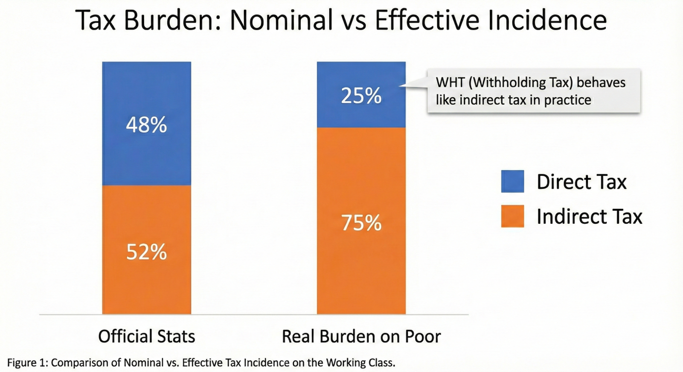

In terms of Defense and Strategic Studies (DSS), this economic inequality brings about Human Insecurity. Barry Buzan, a founder of Copenhagen School of security studies, broadened the concept of security to encompass non-military sectors of economy and society. According to him, the security of the state is something that is closely intertwined with the security of its people. In this situation, which sees the state not as a protector but as a predator, by taking away resources in the form of high utility bills and levies, one can find that the state is the aggressor according to its citizens. This loss of confidence is risky. When the people perceive the state financial machines to be illegitimate, they are unlikely to side with the state in times of crisis. This could be observed in the recent years as the dissatisfaction of the economy quickly transformed into a political manifestation of violence.
The relative deprivation theory by Ted Gurr is most useful in explaining this phenomenon. According to Gurr, the concept of political violence is a result of the disparity between what the people think is their right (basic economic survival and dignity) and what they get. In Pakistan, the economic crisis of cost of living has introduced severe poverty, which is recorded in the Pakistan Development Update by the World Bank (2024) as a "Great Divide" between the poor and the elite. The elite are enjoying tax amnesties, real estate loops and subsidies whereas the working population is being stampeded by taxation of flour and electricity. It is this sense of structural injustice that is the mental fuse to civil turmoil. It is not so that men rebel due to absolute poverty, but as Gurr (2011) warns, due to the feeling of deprivation which is unjust, compared to that of other people in the society.

Section 2: Zakat
If exploitative taxation is the disease that weakens the state, Zakat is the strategic cure that revitalizes it. In Islamic economic theory, Zakat is designed to ensure the Circulation of Wealth (Dawlat). The Quran explicitly warns against wealth circulating only among the rich, stating, "So that it will not be a perpetual distribution among the rich from among you" (Quran, 59:7).
When the rich monopolize such a practice, then the society is torn apart because of the division by classes, which brings in friction and instability. Zakat is seen as a purification device, where excess units send their resources to the deficit units. This economically enhances the marginal propensity to consume by the poor, which boosts the local demand (Shaikh, 2015). Its influence is even more radical, however, strategically. It eases that friction of the class that is the source of internal strife. Western welfare models tend to cause dependency or bureaucracy. On the contrary, Zakat is a transfer of rights; a right of the poor over the rich. This view has been championed by scholars such as Chapra (1992) according to whom Islamic economic justice is the basis of social harmony. The strategic importance of Zakat is that it deprives the hostile actors of space. A closer look at militant groups operating in South Asia, the Tehrik-i-Taliban Pakistan (TTP) and Islamic State Khorasan Province (ISKP), shows a pattern in recruitment that is recurring: they are recruiting by filling the gaps left by the state.
The first narratives constructed by these groups frequently revolve around the concept of justice ($Adl) and Sharia, promising a welfare system that the secular state does not. Young men, who can no longer sustain their families as a result of inflation and taxation, are easy targets of the financial incentives provided by non-state actors (Kilcullen, 2006). An efficient, transparent and state-managed Zakat system is a Strategic Counter-Narrative. The state restores the moral advantage by putting in place a safety net that ensures food, health, and shelter to the neediest. It demonstrates that the Islamic Republic respects its name. This is Soft Power used as internal defense. The "National Zakat Shield" as shown in Figure 2 serves as a firewall, preventing the recruitment activities of anti-state elements by satisfying the economic needs of the weak segment of the population

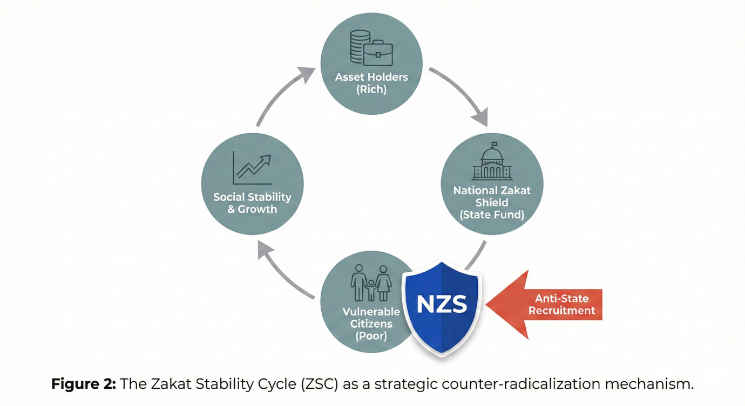

We need to consider the Medina State example not only as religious history, but also as one of the patterns of National Resilience. The Muwakhat (brotherhood) and Zakat made the Prophet (PBUH) system internally so cohesive that it was able to withstand tremendous external military pressure on the side of the Quraysh and other tribes. The Zakat-based economy would bring up the same resilience in the modern Pakistan. A population which feels secure in its state will make the sacrifice of its defence; a population which feels ravaged in its state will make no such sacrific

Section 3: Policy Roadmap - The National Zakat Shield
The Policy Research Institute will need to promote actual structural changes in order to make this vision operational. We cannot just add Zakat to the existing broken system, we have to develop a parallel framework of welfare which generates trust. The government should make the NZS a sovereign welfare fund, which is constitutionally ring-fenced out of the federal budget. Policy Change: NZS has to work autonomously and a board of technocrats, Shariah scholars and members of the civil society will oversee it. Its directive should be strictly Human Security: response to hunger, emergency hospital care, debts write-off (Gharimin). This establishes a direct connection between the State and the Citizen circumventing the uselessness of the traditional bureaucracy (Siddiqi, 2004).
New National Indicators: From GDP to Prosperity We should put aside our fixation on Gross Domestic Product (GDP), which quantifies the size of the economy and not its well being or distribution. The fact that the GDP is high does not imply that 40 percent of the population is food insecure; a security threat, not an achievement.
- Policy Change: Implement Zakat-Linked GDP or "Velocity of Welfare" as a new national indicator. This is used to gauge the speed of the transfer of wealth between the excess holders and the deficit sectors. A fast moving society means a healthy stable society. That agrees with the current economic thinking of inclusive growth that states that inequality is a Vice to long term stability.
- Digitalization to build trust: To fight the notion of corruption, the NZS ought to adopt blockchain technology in the collection and distribution of Zakat. This guarantees a foolproof book of accounts whereby all the Rupees that have been received and given can be traced by the citizens. Winning back confidence in the financial system is a very important element of regaining the confidence in the state itself.

Conclusion

The manner in which the Pakistan defense is undertaken does not start at the Line of Control but in the markets, streets, and homes of Pakistani people. A state which subsists by oppressing its productive class with extortionate levies is constructing its own house upon sand. It is just developing the circumstances of grievance, poverty, and alienation, which its adversaries use in the sphere of hybrid warfare. The final act of national defense is to terminate predatory taxation and to put in place a dignified, state-centered Zakat system. It changes the status of the state to a giver instead of a taker. It seals the social contract fractures and constructs a firewall of Human Security that cannot be overcome by a fifth-generation war strategy. For the sake of our survival, we must understand that in the Islamic Republic of Pakistan, Justice ($Adl$) is the highest form of Security.

References
Buzan, B. (1991). People, states and fear: An agenda for international security studies in the post-cold war era. Brighton, England: Harvester Wheatsheaf.
Chapra, M. U. (1992). Islam and the economic challenge. Leicester, England: The Islamic Foundation.
Federal Board of Revenue. (2024). Revenue division yearbook 2023-24. Islamabad, Pakistan: Author.
Gurr, T. R. (2011). Why men rebel. London, England: Routledge.
Kilcullen, D. (2006). Counter-insurgency redux. Survival, 48(4), 111-130.
Pakistan Institute of Development Economics. (2024). Tax reforms: Revenue with growth. Islamabad, Pakistan: Author.
Shaikh, S. A. (2015). Welfare potential of Zakat: An attempt to estimate economy wide Zakat collection in Pakistan. Journal of Islamic Economics, Banking and Finance, 113(3), 15-32.
Siddiqi, M. N. (2004). Riba, bank interest and the rationale of its prohibition. Jeddah, Saudi Arabia: Islamic Research and Training Institute.
World Bank. (2024). Pakistan development update: The dynamics of power sector distribution reforms. Washington, DC: World Bank Group.

