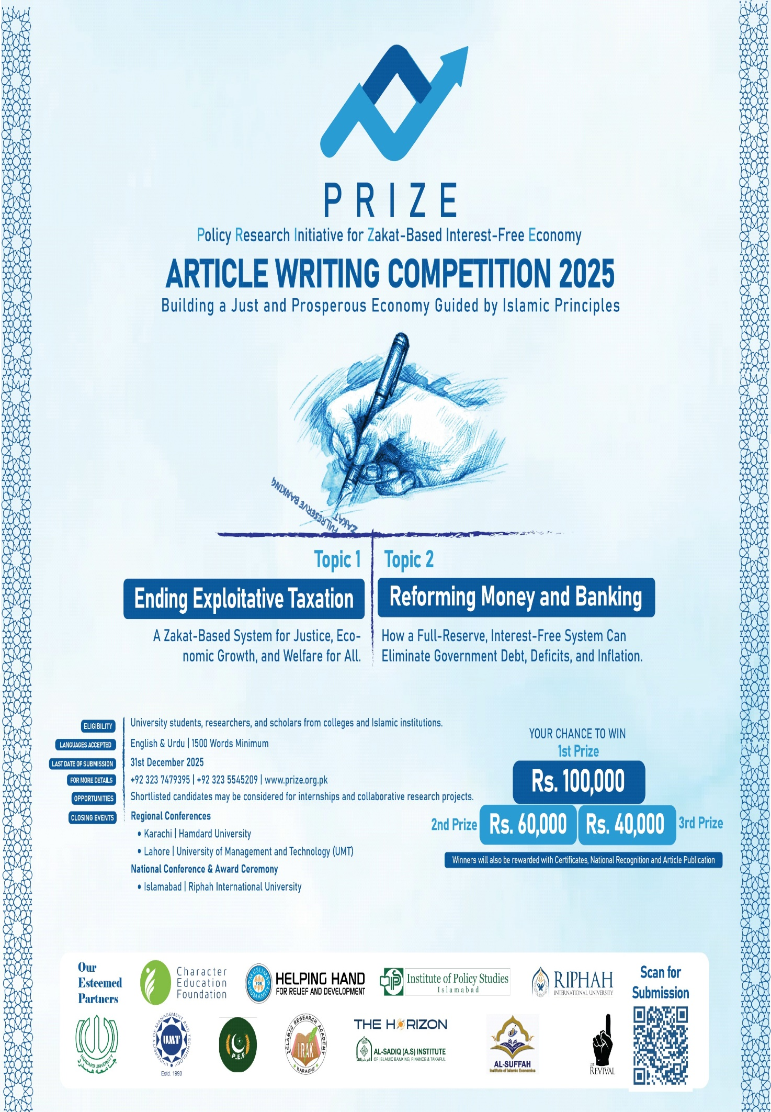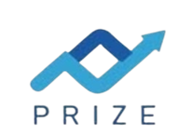

TOPIC 1 : ENDING EXPLOITATIVE TAXATION
A Zakat-Based System for Justice, Economic Growth, and Welfare for All.

Pakistan’s economic crisis is usually discussed in the sterile, technical language of technocrats—fiscal deficits, IMF programs, or foreign reserves—but these terms rarely capture the everyday struggles of ordinary people. For most Pakistanis, the crisis is not a data point; it shows up in grocery bills, electricity charges, and the rising cost of commuting to work. At its core, this is not just a financial problem; it is a deep crisis of fairness. The tax system consistently targets those with little power while allowing wealthy elites, large corporations, and politically connected individuals to escape meaningful contribution. Salaried workers, small business owners, and ordinary consumers bear the brunt, while powerful landlords and influential industrialists remain largely untaxed. This imbalance makes paying taxes feel less like a civic duty and more like an extraction of wealth from the vulnerable to protect the powerful. For the average Pakistani like you and me, the system feels rigged to favor those already advantaged, eroding trust and building frustration that has grown over decades. Over time, this unfairness feeds a broader sense of hopelessness, as families struggle to plan their futures while seeing little accountability from those who have the means to help sustain the country’s economy. The perception is clear: the middle class is punished for its visibility, the poor are suffocated by consumption taxes, and the wealthy escape through the back door of influence. This is the real social cost of a system built around convenience rather than justice.
Historically, Pakistan has relied on indirect taxation because it is easier to collect, but this convenience comes at a moral and social price. Every time the state raises the General Sales Tax on essentials or adds a surcharge on electricity, it disproportionately targets those least able to pay, further widening the inequality gap. The long-term effect is not just economic—it is social unrest, a decline in public trust, and a weakened sense of national cohesion.
One of the clearest signs of this imbalance is the over-reliance on indirect taxes, which disproportionately affect lower-income households. Sales tax on food, electricity surcharges, mobile phone levies, and fuel duties hit everyone, but not equally. When the price of a liter of petrol hits 270 PKR, the levy included in that price is not just a number—it becomes a real, painful sacrifice. For families living on the edge, it translates into a meal skipped, a school fee postponed, or a medical visit delayed. Ordinary workers spend nearly their entire income on essentials, meaning these taxes act as a tax on survival. For wealthier households, these charges barely affect their lifestyle. Salaried individuals are also trapped by withholding taxes automatically deducted from pay, leaving no room for planning or adjustment. I have seen firsthand how a small shopkeeper in a local neighborhood trembles when an FBR notice arrives, fearing the confusion and harassment of a system he cannot navigate, while the owner of the massive plaza next door remains unbothered thanks to political connections. This creates a moral breakdown; when compliance is punished and influence rewarded, tax avoidance becomes a survival tactic rather than a crime. The recent protests by traders in Karachi’s Saddar area against rising levies highlighted this frustration, showing how everyday business owners feel squeezed between government demands and their own survival.
In addition, frequent changes in tax rates and surcharges create uncertainty for families and businesses alike, forcing many into short-term coping strategies rather than long-term planning. The psychological impact of this system is rarely measured but is deeply felt: people plan their days, weeks, and even months around the rising cost of fuel, electricity, and essential goods. Every hike in indirect taxes is felt not just financially, but socially, as families cut back on meals, transport, and education. The gap between the average citizen and the wealthy grows visibly, reinforcing the perception that the system is fundamentally unfair and skewed.
The real silence, however, is found in the vast acres of our rural heartlands and the speculative "plot culture" of our cities. The lanes of Liberty in Lahore or Jodia Bazaar in Karachi host vibrant retail economies, yet much of it operates without documentation and dominated by cash transactions. But the greatest injustice lies in real estate. Land in Pakistan is often used not for productivity, but as a parking lot for untaxed wealth. We have created a "plot culture" where the elite buy huge tracts of land in gated communities like DHA or Bahria Town, waiting for prices to skyrocket without building anything. This speculative bubble has made housing unaffordable for ordinary citizens while the government collects almost nothing in capital gains or wealth tax. It is ironic that a luxury plot in a posh housing scheme is taxed less than the electricity bill of a two-bedroom apartment in a lower-middle-class colony. Large landowners in agriculture enjoy constitutional loopholes and provincial protection. While small farmers struggle with rising costs for seed, fertilizer, and water, the feudal elite shield their massive incomes from taxes. Over decades, governments have reinforced this imbalance through amnesties and special concessions, prioritizing political survival over fairness. These “untouchables” reveal the structural rot in our system. Informal sectors like roadside vendors face harassment from local officials, while the invisible wealth in speculative real estate grows unchecked. The contrast is stark, and every new luxury housing project reinforces the sense of injustice in the middle and lower classes. Moreover, urban speculation indirectly affects rural life: rising land prices in cities push more people to buy plots in suburban or peri-urban areas, inflating costs for infrastructure, water access, and public services. Even those working hard to earn a living feel trapped, unable to compete with those whose wealth is inherited or sheltered by policy loopholes. The system’s inequity extends across generations, entrenching social stratification and leaving ordinary Pakistanis to cope with rising prices, limited opportunities, and little hope of upward mobility.
This inequity has created a profound trust deficit between citizens and the state. In Pakistan, we pay taxes and then pay again—for schools, hospitals, clean water, and security. In a functioning democracy, taxation is a contract: you pay the state, and the state provides services. Here, that contract is broken. Parents rely on private schools because public education is underfunded and poorly managed. Families turn to private clinics due to overcrowded hospitals or lack of medicine. Gated communities hire private security because law enforcement cannot provide reliable protection. Even safe drinking water often has to be bought from private suppliers. Observing this daily, people naturally ask: "Where is my tax money going?" The answer often appears in the luxury SUVs, sprawling government bungalows, and high allowances for bureaucrats. This "double burden" explains why many resist paying taxes. People are not inherently dishonest; they are simply tired of paying for a state that does not look after them. The recent news that the IMF approved a new tranche under strict fiscal conditions has only intensified this anxiety. Most know that “fiscal adjustment” usually translates to higher bills for ordinary citizens, not reduced perks for officials. Without a visible link between tax collection and public benefits, compliance will always feel like forced extraction. Moreover, the emotional toll is heavy: seeing repeated government mismanagement and misallocation of funds can lead to cynicism and apathy, reducing civic engagement. Families feel caught in a loop of paying twice, yet receiving little, which undermines social cohesion. The state’s inability to deliver even basic services consistently adds to frustration, making ordinary citizens skeptical of any new tax reforms or promises of accountability.
Beyond fairness, there is also an economic cost to this inequality. When wealth is concentrated in the hands of a few, purchasing power across the economy shrinks. Small businesses—often the engine of local employment—suffer from reduced demand, limiting their ability to grow and hire more workers. Inequitable taxation discourages entrepreneurship because starting a new venture under constant scrutiny, high surcharges, and unpredictable levies feels riskier than investing in untaxed luxury assets. The system inadvertently promotes hoarding and speculation rather than productive investment. Furthermore, this lack of fairness fuels brain drain: talented professionals, seeing little chance of financial justice or merit-based progress, leave the country in search of better opportunities. The result is a dual loss: not only are public revenues stunted, but human capital—critical for innovation and development—is drained away.
Pakistan must reform its tax system fundamentally to survive. We must shift toward direct taxation, where those who earn more and own more contribute more. This means documenting the retail sector from Liberty to Jodia Bazaar, taxing real estate at actual market value, and ending the tax-free status of large landholdings. The tax code must be simplified so that the average citizen can understand it without a lawyer. More importantly, the state must link revenue visibly to public services. If people see their money building schools, fixing roads, and improving hospitals, their willingness to pay will increase. We must also end the culture of repeated “tax amnesties” that reward those hiding wealth while penalizing those who comply honestly. Beyond fiscal fairness, this shift is a moral imperative: a society that taxes survival but shields wealth cannot maintain social trust. The choice is existential: if we continue to squeeze the middle class while protecting the powerful, the best and brightest will continue to leave for fairer systems abroad. Reforming the tax system is not just about raising revenue; it is about rebuilding faith in the state, restoring social contracts, and giving ordinary citizens the sense that their hard work contributes to a fairer, more sustainable future. Cosmetic changes will no longer suffice; Pakistan needs a fair deal for its citizens now. Without this reckoning, economic crisis will remain a story of numbers on paper—but for the majority, it will continue to be a story of missed meals, broken dreams, and a society that forgets those who built it.
Word Count: 1639 words | 10,751 characters

Written By
Muhammad Usman Khan
From
NED University Of Engineering & Technology, Karachi.

