The Crisis of Modern Banking and the Islamic Alternative :
A Roadmap for Full-Reserve Banking and Economic
Stability

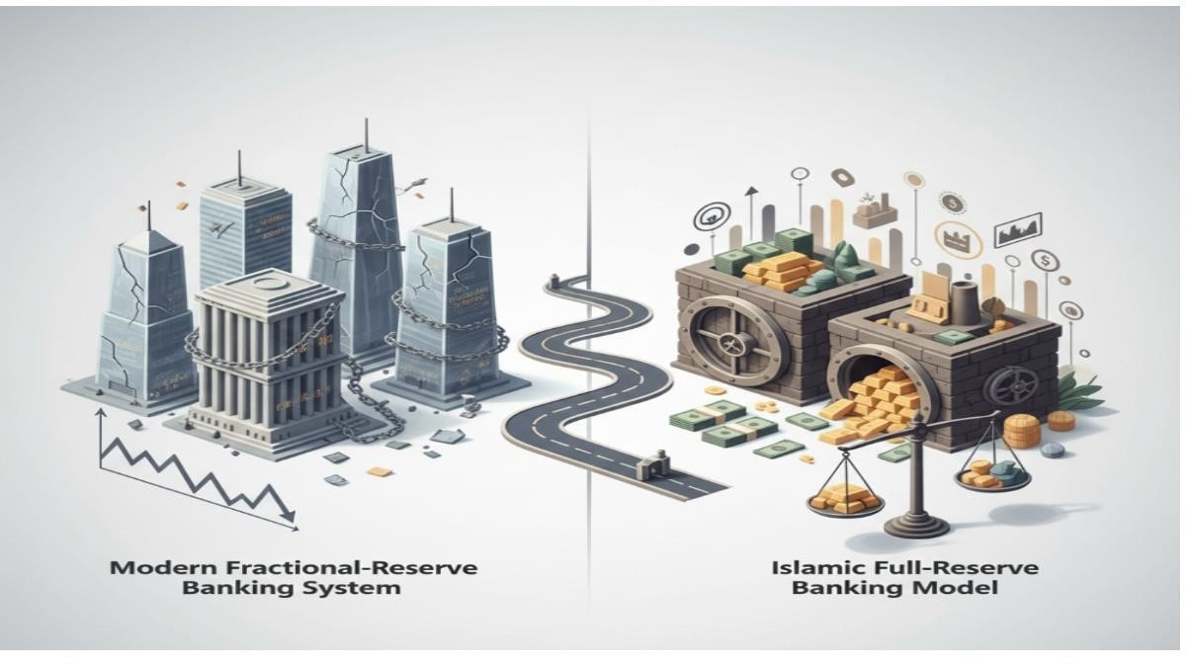
From Debt to Stability: Transitioning from Fractional-Reserve Chaos to the Islamic FullReserve Model.
Introduction

The Global Economic Crossroad
The 21st-century global economy stands at a critical juncture where the apparent glitz and glamour of financial markets are built on a foundation of sand.
The current capitalist system, deeply rooted in Usury (Riba) and debt-based expansion, has trapped humanity in a labyrinth where the path to financial freedom seems impossible for the common man.
From developing nations like Pakistan to global superpowers, almost every sovereign entity is crushed under a mountain of debt.

This crisis is not accidental
It is the direct result of an exploitative banking system that “creates money out of thin air.”
Islam, as a complete code of life, offers a robust economic framework based on justice, transparency, and tangible production.
This article examines the fundamental flaw of the current system—Fractional Reserve Banking—and proposes a revolutionary transition toward Full-Reserve Banking and a localized Zakat-based economy.

The Core Malady: Fractional Reserve Banking
The global financial infrastructure relies on Fractional Reserve Banking.
In this system, when a customer deposits a certain amount, the bank is required to keep only a small fraction (e.g.,10%) as a reserve and is permitted to lend out the remaining 90%.
This process is repeated cyclically across the banking sector, allowing institutions to create “Scriptural Money” or phantom wealth that has no physical existence.
The consequences of this artificial money creation are catastrophic
The Storm of Inflation: When the circulation of “phantom money” outpaces the actual production of goods and services, the currency inevitably loses its value.
This leads to hyperinflation, diminishing the purchasing power of the masses while banks continue to accumulate wealth through interest. The Debt-Trap Cycle
In the current paradigm, money enters the economy only as debt.
If all debts were settled, the circulating currency would virtually disappear.
This systemic flaw traps nations in a state of permanent “debt addiction.”

Systemic Instability
Since banks do not hold the full amount of their customers’ deposits, they remain perpetually vulnerable to “bank runs.”
A sudden demand for cash by depositors can lead to a total collapse of the banking sector, dragging the national economy into a depression.

Full-Reserve Banking
The Islamic Economic Cornerstone
The definitive solution to these systemic crises lies in a Full-Reserve, Interest-Free System.
Full-Reserve Banking mandates that financial institutions must keep 100% of demand deposits in their vaults.
Banks are strictly prohibited from lending this money or using it for speculative investments.
The implementation of this system would yield transformative benefits
Elimination of Sovereign Deficits
When private banks lose the power to manufacture money, governments will no longer be forced to borrow at high interest rates from private entities.
Instead, the State, through the Central Bank, will issue currency based on real economic output.

Monetary Stability
By aligning the money supply with tangible assets and real-world production, the inflation graph will stabilize, protecting the value of the citizens’ savings.

Reimagining Financial Institutions
Banks will evolve from exploitative credit-creators into “Safe Keepers” (charging service fees) or “Investment Partners” based on the Islamic principle of Mudarabah (Profit-andLoss Sharing).

The Burden of Debt vs. The Power of Zakat
As of late 2025, Pakistan’s total external debt and liabilities have reached a staggering estimated figure of $140 Billion.
With a population of nearly 250 Million (including Pakistan and Azad Jammu & Kashmir), the per capita burden is devastating.
Individual Liability
Every citizen, including newborns, now carries a debt of approximately 160,000 PKR.

Daily Interest Accrual
Due to compound interest and currency fluctuations, this debt increases at an estimated daily rate of 0.05% to 0.1%, relentlessly suffocating the middle and lower classes.

Indirect Taxation
To service this usurious debt, citizens pay roughly 20% to 25% of their income in hidden taxes on essential commodities like electricity, flour, and fuel.

In contrast, the Islamic economic model provides a dignified alternative through Zakat. By collecting 2.5% of surplus wealth annually, capital is prevented from stagnating. Zakat is not mere charity
It is a sophisticated institutional tool that ensures wealth circulates from the wealthy back into the productive economy.

Socio-Economic Realities: The AJ&K Perspective
The disconnect between the interest-based system and public welfare is evident in the recent socio-political movements in Azad Jammu & Kashmir (AJ&K). The rise of Public Action Committees (PACs) is a direct reaction to the economic strangulation caused by inflation and unemployment.
The PAC’s 38-point Charter of Demand, which successfully challenged traditional political structures in districts like Bagh and Rawalakot, highlighted a crucial reality: the people are no longer willing to bear the cost of elite privileges and a debt-ridden administration.
Demands for the abolition of unnecessary administrative seats and the reduction of cabinet sizes were more than political slogans—they were cries for economic justice. While the government eventually yielded under public pressure, the long-term implementation remains hindered by the IMF’s compound interest traps. The “interest termite” continues to hollow out national progress, leaving the state vulnerable to internal strife and Fifth Generation Warfare.

Proposed Roadmap for Reform
To reclaim economic sovereignty, we propose the following strategic shifts:

1. Grassroots Zakat Committees
Establishing autonomous Zakat Committees at the neighborhood level, led by verified local chairpersons.

2. The 70/30 Distribution Model
70% of collected Zakat and Ushr should be reinvested locally to create dignified jobs and small-scale industries.
The remaining 30% should be allocated to the National Treasury to systematically retire foreign debts.

3. Asset-Backed Digital Currency
Transitioning from paper fiat to a digital currency backed by Gold or Agricultural Commodities via Blockchain Technology.
This ensures transparency in Zakat collection and eliminates the possibility of “printing” inflation.

4. Institutional Awareness
Universities, such as the Women’s University Bagh, must serve as hubs for researching these Islamic economic alternatives, preparing a new generation of researchers to lead a post-interest economy.

The Spiritual and Moral Imperative: Divine Warnings Against Usury
The economic crisis we face is not merely a failure of policy; it is a consequence of defying divine wisdom.
The Quranic declaration against interest is uncompromising, categorizing Riba (Usury) not just as a sin, but as an act of defiance against the Creator.

Allah (SWT) says in the Holy Quran
“O you who have believed, fear Allah and give up what remains [due to you] of interest, if you should be believers.
And if you do not, then be informed of a war [against you] from Allah and His Messenger” (Al-Baqarah: 278-279).
The severity of this “War” is evident in our crumbling economy, where, despite massive resources, the common man remains enslaved.
The Holy Prophet Muhammad (PBUH) further emphasized the destructive nature of interest in several Sahih Hadiths, leaving no room for ambiguity:

The Gravity of the Sin
The Prophet (PBUH) said, “A dirham which a man knowingly consumes in usury is worse than thirty-six acts of adultery” (Musnad Ahmad).
This comparison illustrates that while social sins harm individuals, the economic sin of Riba destroys entire civilizations and the fabric of justice.

The Curse of Involvement
In another narration from Sahih Muslim, Jabir (RA) reported that the Messenger of Allah (PBUH) cursed the one who consumes interest, the one who pays it, the one who writes it down, and the two who witness it, saying:

“They are all equal (in sin).”
This highlights that the entire framework of modern fractional banking, which relies on recording and witnessing interest-based debt, is inherently flawed.

The Mirage of Wealth
The Prophet (PBUH) also warned: “Even if usury increases wealth, its end will be poverty and scarcity” (Ibn Majah). We see this today in nations that borrow billions; the numbers on paper increase, but the actual prosperity and purchasing power of the people vanish.
Zakat

The Divine Mechanism for Wealth Circulation
While the capitalist system hoards wealth in the hands of a few, the Islamic system mandates its flow.
The Prophet (PBUH) instructed Mu’adh bin Jabal (RA) when sending him to Yemen:
“Inform them that Allah has made it obligatory upon them to pay Zakat from their property, which is to be taken from the wealthy among them and given to the poor among them” (Sahih Bukhari).
If we implement this at the grassroots level in Pakistan and AJ&K, it creates a selfsustaining cycle.
Imagine every neighborhood in Bagh, Rawalakot, and Muzaffarabad having a local Zakat treasury.
By investing 70% of these funds into local micro-businesses, we replace “debtors” with “owners.”
This is the “Full-Reserve” philosophy in action—where money is backed by real people, real skills, and real assets, not by interest-bearing “phantom” entries in a bank’s ledger.

A Call to Intellectual and Spiritual Sovereignty
Transitioning to an Islamic economic system is not a retreat into the past;
It is a leap into a more stable and just future. The current global unrest, the “Public Action Committees” in AJ&K, and the mounting frustration of the youth are all symptoms of a thirst for justice.

By purging our system of Riba, we are not just fixing an economy
We are reclaiming our dignity and seeking the Barakah (Blessing) that has been missing from our national life.
It is time to realize that the solutions offered by the IMF are like drinking salt water—they only increase the thirst for more debt. Our salvation lies in the Roadmap of Medina, where wealth was a means to serve humanity, not a tool to enslave it.
Conclusion

From Seekers to Givers
The current interest-based system is a setting sun, casting long shadows of poverty and inequality across the globe. Transitioning to a Full-Reserve, Interest-Free Economy is not merely a religious sentiment; it is a scientific necessity for survival in the modern age.
By reviving the spirit of Zakat and dismantling the exploitative machinery of fractional reserves, Pakistan and AJ&K can transform their destiny within a decade. Our goal is to shift from a nation of “debt-seekers” to a nation of “Zakat-givers”—a sovereign state that assists others through justice rather than enslaving them through usury.
The time has come to replace paper-based debt traps with value-based economic justice, ensuring that the dignity of the people and the sanctity of the State are never again compromised.

