TOPIC A Zakat-Based System for Justice, Economic Growth, and Welfare for All
Presentation
Taxes have always been at the heart of national politics, but for millions of citizens they are seen less as a contribution than as a burden. Complex rules, overlapping taxes, hidden fees and regressive systems turn what should be a fair civic duty into an exploitative structure. In many countries – including several Muslim-majority countries – people pay income tax, sales tax, GST, service fees, excise taxes, fuel taxes, withholding taxes, banking transaction taxes and countless indirect fees. Despite this significant extraction, public welfare remains poor, poverty remains high, and inequality continues to grow.
Islam offers a radically different approach based on simplicity, fairness, moral responsibility and economic empowerment. This approach is Zakat – a God-ordained system that aims to strengthen society by transferring wealth from stagnant hands to productive and needy hands. Unlike modern taxation, the aim of zakat is not to generate income, but rather to achieve social justice, the eradication of poverty and a fair distribution of wealth.
A tax system based on Zakat is not only a spiritual principle: it is also economically efficient, administratively simple and socially transformative. This article explains how replacing exploitative taxation with a zakat-centric model can reduce inequality, strengthen public welfare and stimulate sustainable economic growth.
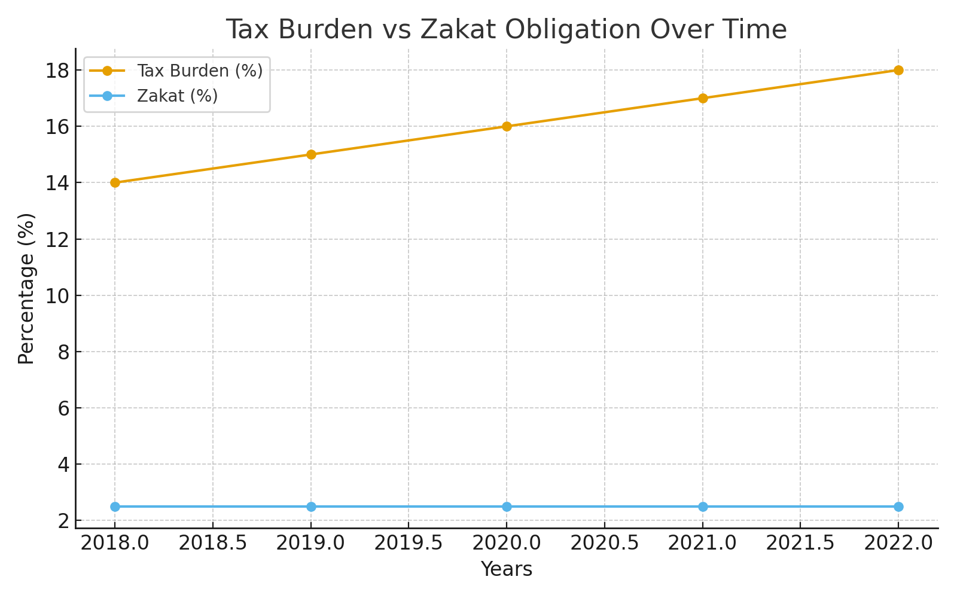
1. The problems of modern taxation
a) Excessive reliance on indirect taxes
Most developing countries rely on GST/VAT, sales tax, electricity surcharges, fuel taxes, cell phone taxes and bank charges. These indirect taxes:
- Hit the poor harder than the rich
- Increase the cost of essential items
- Reduce purchasing power
- Prevent consumption
- Fuel inflation
- Create a cycle of poverty
A poor mother who buys bread pays the same tax as a millionaire who buys imported snacks – this alone shows how unfair the current model is.
b) Taxation without a trust
Governments promise well-being but often offer:
- Broken streets
- Underfunded hospitals
- Bad education
- Bribery
- Lack of transparency
- Waste of public money
- People pay taxes but don't see results. Consequently:

- Citizens avoid taxes
- Governments continue to raise taxes
- The economy is slowing
- The cycle of distrust deepens
- A system based on coercion rather than trust will eventually collapse.

c) High administrative costs

Modern taxation requires enormous bureaucratic efforts to collect, enforce, audit, investigate and prosecute. Billions are spent just to collect taxes. This creates:
- Inefficiency
- Greater opportunities for corruption
- Higher costs of doing business
- 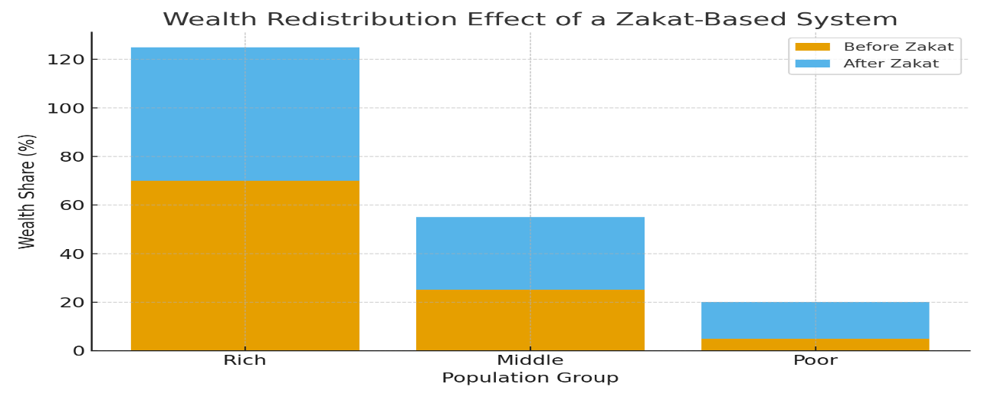
2. Zakat: a divine alternative to economic justice
Zakat is not just a religious obligation: it is an economic system. Designed by Allah, it creates a natural and sustainable mechanism for the circulation of wealth. Zakat embodies four unique characteristics:
i) It's easy
Only 2.5% on unused assets, once a year.
ii) It targets the root of poverty
The funds go directly to the poor, debtors, travelers, the needy and those in distress due to circumstances.
iii) He is moral and willful in his mind
People donate knowing it is an act of worship. This increases compliance, unlike taxation which increases tax evasion.\
iv) It discourages hoarding and encourages investment
Zakat applies to unused cash, gold, property and savings. If you leave your wealth unused, it slowly diminishes due to zakat, which naturally pushes people towards:
- Investment
- Business expansion
- Create jobs
- Economic activity

3. How a zakat-based system can replace exploitation taxes
a) Abolition of indirect taxes

- Replacing GST/VAT, sales tax and consumption taxes with Zakat income:
- Prices drop
- Purchasing power increases
- Inflation is decreasing
- Businesses grow naturally
- A tax-free consumption environment stimulates the economy and ensures that poor families can live with dignity.
b) Financing welfare with zakat
- Historically, Islamic rule included:
- Free education
- Free healthcare
- Wages for the poor
- Homes for widows and orphans
- Traveler support
- Help for people with debts
- Zakat can fully fund welfare programs because it directly targets the exact groups that need support.
c) Drastically reduce poverty

- A well-managed Zakat system:
- Eliminate hunger
- It offers interest-free loans
- Support small entrepreneurs
- Help farmers and artisans
- It empowers widows and young people
- Creates long-term financial independence
- Instead of giving charity that lasts a day, Zakat creates permanent uplift.
d) Encourage investment and entrepreneurship
Because Zakat punishes hoarding, wealthy individuals naturally invest more in:
- Companies
- Startups
- Agriculture

- Technology
- Real estate development
- Production
- This expands the economy, increases employment and increases national prosperity. 4. Zakat + modern tools: a hybrid model of Islamic budgeting
- A modern Islamic welfare state can integrate:
- Digital Zakat Collection
- National Zakat Database
- Fight against poverty based on artificial intelligence
- Transparent dashboards
- Blockchain surveillance
- Mobile payment systems
- This reduces corruption and increases trust by allowing every citizen to see how zakat is collected and spent.

5. Case studies and historical testimonies
a) Caliph Umar ibn Abdul Aziz
During his reign, the distribution of zakat was so effective that no one was deemed eligible to receive it. Poverty has almost disappeared.
b) Malaysia and Indonesia
These countries use centralized Zakat authorities which:
- Financing education
- Support small businesses
- Reduce the use of interest rate loans
c) Pakistan (late 1980s system)
The Zakat and Ushr regulations have shown that even partial implementation can generate billions of dollars for welfare.
6. The economic advantages of a system based on Zakat
✔ Reduce inequalities
Wealth moves from useless savings to productive and needy hands.
✔ Reduced inflation
No taxes on products → lower prices → stronger purchasing power.
✔ Higher investment

Zakat discourages hoarding and encourages entrepreneurship. ✔ Effective management
Collecting Zakat is much easier and less expensive than going through the tax bureaucracy.
✔ Spiritual responsibility
People contribute willingly because it is worship, not coercion.
7. Address Concerns
“Can Zakat replace all taxes? »
Not immediately – but it can replace most indirect taxes and significantly reduce the rest.
“Will the government lose revenue?
No. Zakat increases economic activity, which increases the overall well-being of society. A wealthier society requires fewer taxes.
“Is this system practical today?
With digital tools and transparent frameworks, it’s now more convenient than ever.
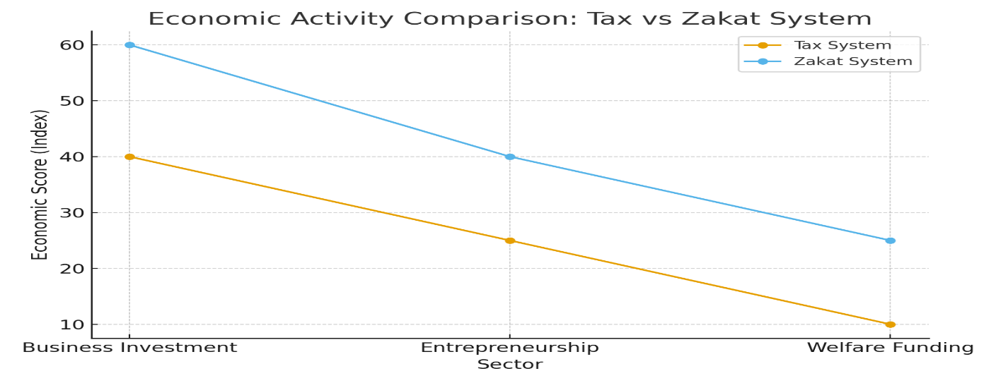
Conclusion

Modern tax systems have become cumbersome, regressive and exploitative. They extract more than they reinforce, and they widen inequalities rather than reduce them. In contrast, Islam's Zakat system offers a spiritual and economically efficient alternative based on justice, compassion and social up liftment.
A tax model based on Zakat:
- Reduces poverty
- Reduces inequalities
- Promotes investment
- Promotes well-being
- Reduces inflation
- Strengthens trust between citizens and government

It is not just a theological concept, but a complete economic system capable of replacing exploitation taxes and transforming society into one that preserves dignity, justice and prosperity for all.

By adopting Zakat as a central pillar of national policy, nations can move from a system of withdrawal to one of augmentation, creating an economy in which every citizen has the opportunity to live with honor, security and hope.
WRITTEN BY ATTIA ZULFIQAR
BRAND EMBASSODAR
REFERAL ID 667

